Prompt Engineering Foundations

Student Name: Chirag Pathania
Roll No.: 2520992571
Course: Chitkara University CBS BBA Fintech & AI
Section: i1

Content of Table

Sr. no. | Title | Page no.
1 | Prompt Concepts and clarifications | 3
2 | Chat GPT | 4-15
3 | Claude | 16-24
4 | Perplexity | 25-32
5 | Gemini | 33-41
6 | Key Finding | 42-43

Prompt Concept

Prompt Engineering means creating clear and specific instructions for AI to get better and more useful responses. A good prompt usually includes Role, Context, Task and Format (RCTF).
Zero-Shot Prompting means giving instructions without examples, while Few-Shot Prompting means giving a few examples before asking AI to perform a task.
Prompt Engineering is useful in Marketing, HR, Finance and Operations. If the AI gives a poor answer, we can improve the prompt and try again.
Finally, AI-generated answers should always be checked for accuracy, relevance, completeness, bias and evidence. Confidential information should not be shared with AI tools.

Models Used for Prompt Engineering
For this project, we utilize baseline versions of leading Large Language Models (LLMs) to ensure consistency and comparability across different platforms. The selected models are:
- ChatGPT – GPT-3.5 OpenAI’s widely adopted model, chosen for its balance of performance and accessibility.
- Claude – Sonnet 5 Medium Anthropic’s mid-tier model, optimized for reasoning and structured responses.
- Perplexity – Free Model The freely available version of Perplexity AI, included to benchmark cost-effective solutions.
- Gemini – Flash Model Google DeepMind’s lightweight model, designed for speed and efficiency in real-time tasks.

Chat GPT

Finance Department

Problem Statement 1:
The finance department struggles to accurately forecast budgets due to fluctuating expenses and unpredictable revenue streams.

Basic Prompt:
My finance department is struggling in predicting the expenses and revenue steam what to do?

Output:
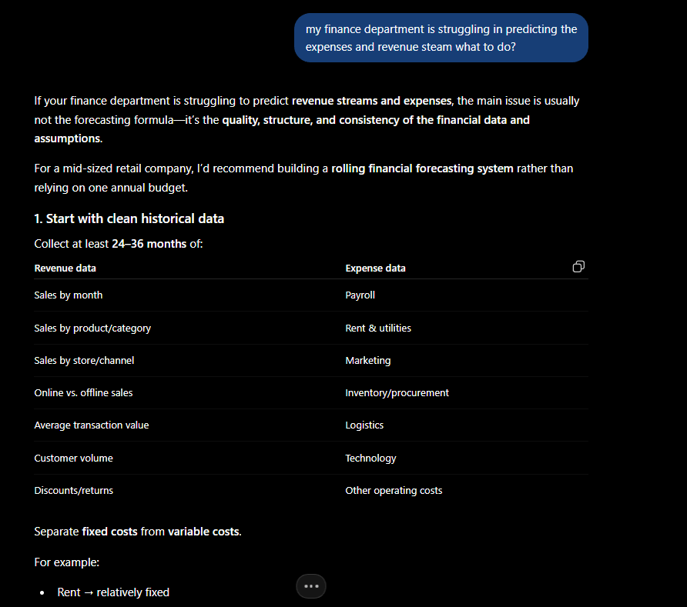

Type 1

Improved Prompt:
Act as a financial analyst. Our company is a mid-sized retail firm. Our target audience is internal management and stakeholders. Create a detailed expense and revenue forecasting report using historical financial data, seasonal trends, and market growth indicators. Present the output as a structured business report with clear tables, charts, and actionable recommendations.

Output:
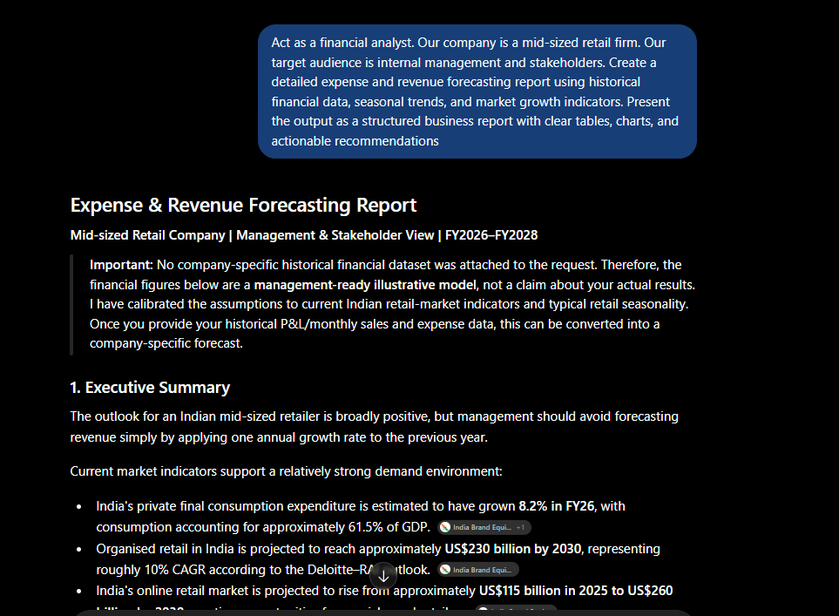

Type 2

Improved Prompt:
Act as a financial analyst. Our company is a mid-sized retail firm. Our target audience is internal management and stakeholders. Create a detailed expense and revenue forecasting report using historical financial data, seasonal trends, and market growth indicators. Present the output as a structured business report with clear tables, charts, and actionable recommendations.

Example:
Forecast revenue of JPMorgan in Q2 based on market growth and historical performance.
Now, using the same style, generate a forecast for our company’s expenses and revenue streams for the upcoming financial year. Take synthetic numbers.

Output:
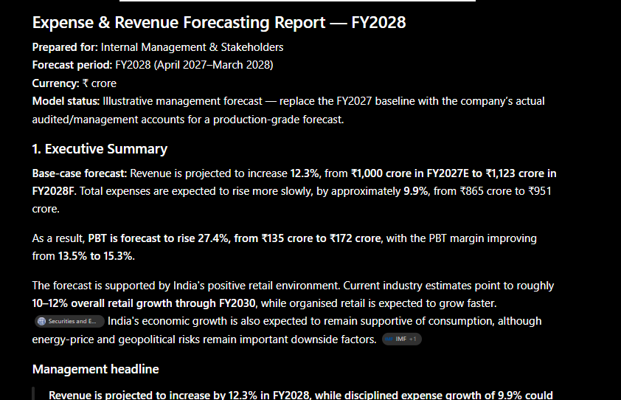

Problem Statement 2:
The finance department is struggling to detect fraudulent transactions effectively, as suspicious activities are often hidden within massive volumes of complex financial data, making timely identification and prevention difficult.

Basic Prompt
There is so much suspicious transaction in company which lead to high loses

Output
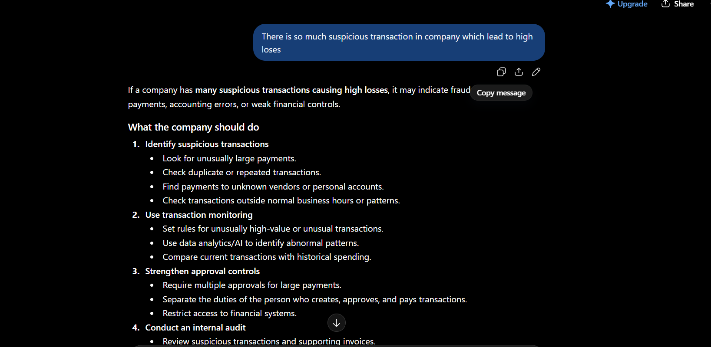

Improved Prompt (Type 1):
Act as a compliance and fraud risk analyst. Our company is a mid-sized financial services firm. Our target audience is internal management and regulatory stakeholders. Create a detailed fraud detection report that analyses transaction patterns, highlights suspicious anomalies hidden in large datasets, and recommends preventive measures. Present the output as a structured business report with clear tables, charts, and actionable recommendations.

Output:
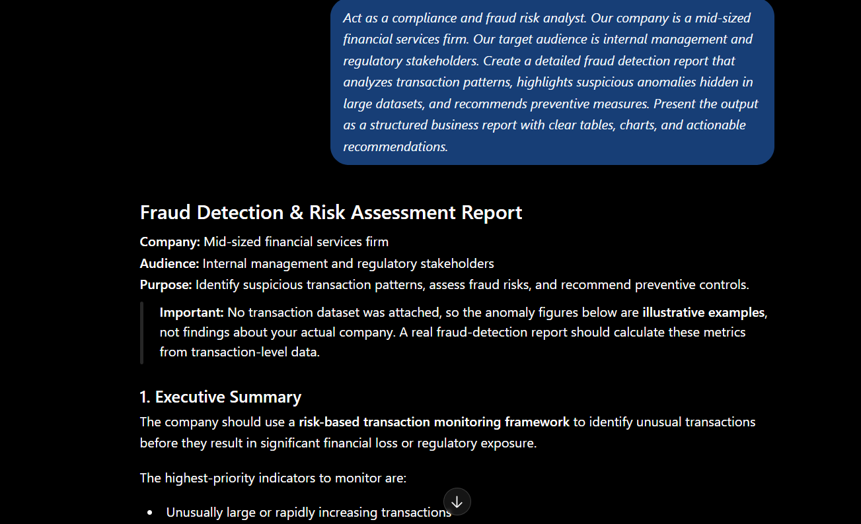

Improved Prompt (Type 2):
Act as a compliance and fraud risk analyst. Our company is a mid-sized financial services firm. Our target audience is internal management and regulatory stakeholders.
Create a detailed fraud detection report that analyses transaction patterns, highlights suspicious anomalies hidden in large datasets, and recommends preventive measures.
Present the output as a structured business report with clear tables, charts, and actionable recommendations.

Example:
Input: "Detect anomalies in JPMorgan’s credit card transactions for Q2."
Output: "Suspicious activity identified in high-value overseas transactions with unusual frequency. Recommended preventive measures include enhanced verification protocols and real-time monitoring."

Now, using the same style, generate a fraud detection report for our company’s financial transactions.

Output:
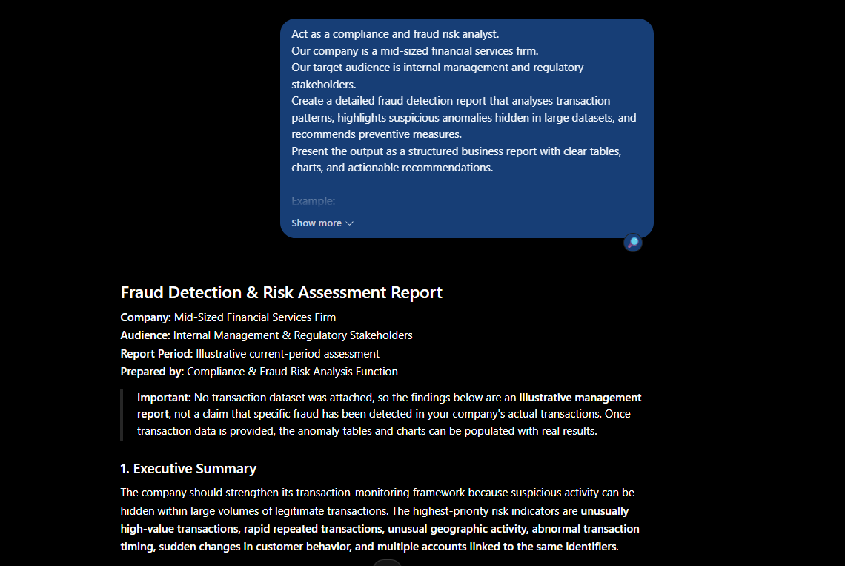

HR Department:

Problem statement:
The HR department finds it difficult to conduct fair and consistent performance evaluations across diverse teams, resulting in employee dissatisfaction and reduced productivity.

Basic Prompt:
Company is facing problem to tracking the work of the employe which is creating the problem. How to solve?

Output:
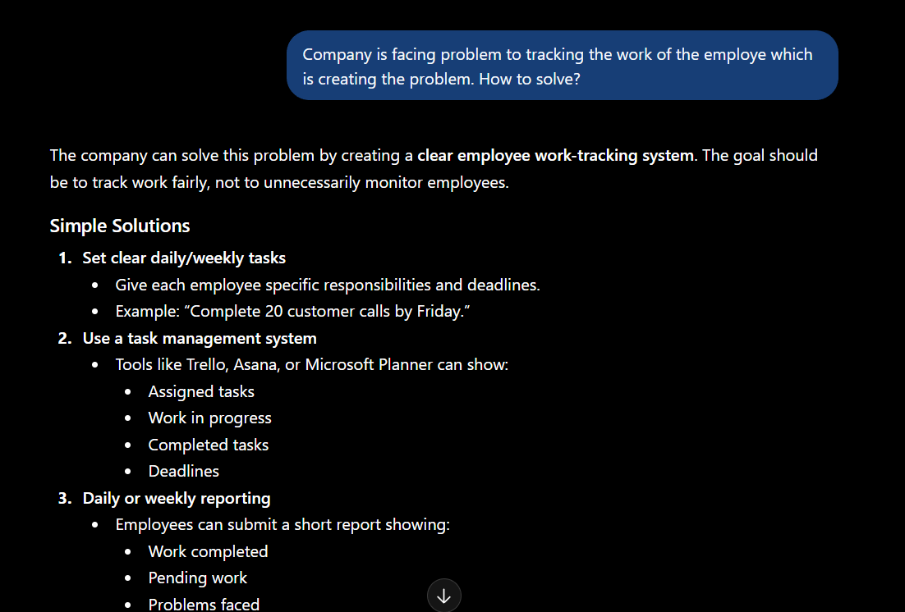

Improved Prompt (Type 1):
Act as a human resources consultant. Our company is a mid-sized technology firm. Our target audience is HR leadership and department managers. Create a comprehensive performance evaluation framework that ensures fairness and consistency across diverse teams, identifies key performance indicators, and provides actionable recommendations to improve employee satisfaction and productivity. Present the output as a structured HR report with clear tables, rating scales, and practical guidelines.

Output:
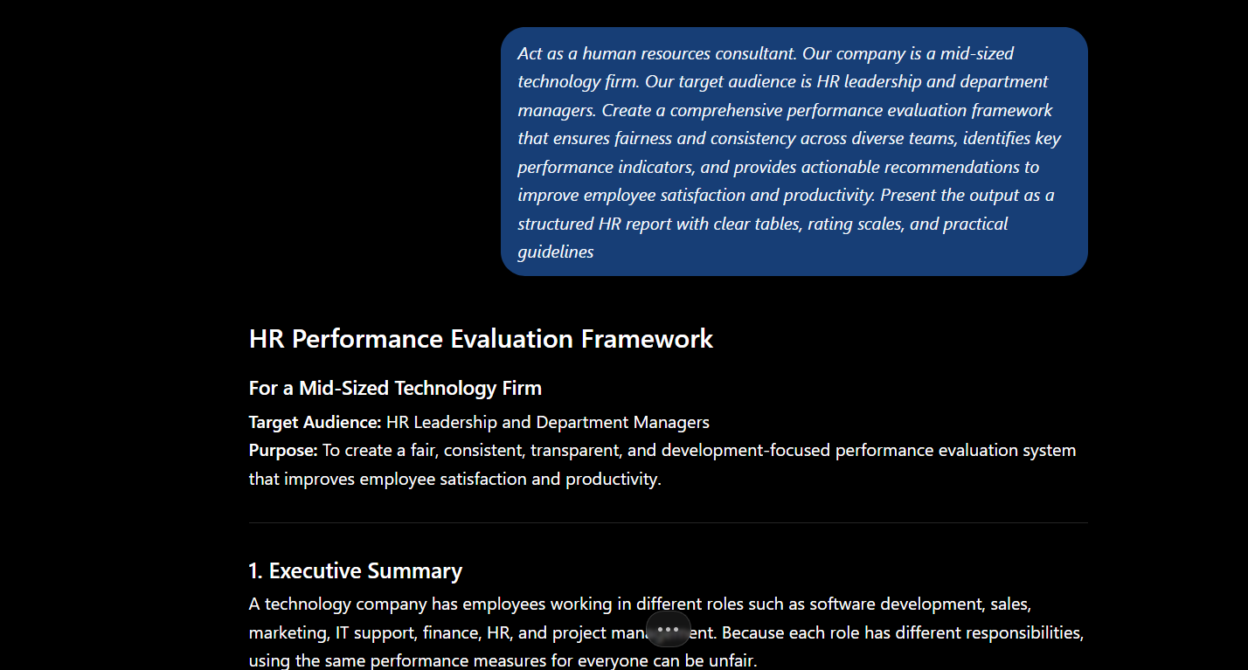

Improved Prompt (Type 2):
Act as a human resources consultant. Our company is a mid-sized technology firm. Our target audience is HR leadership and department managers. Create a comprehensive performance evaluation framework that ensures fairness and consistency across diverse teams, identifies key performance indicators, and provides actionable recommendations to improve employee satisfaction and productivity. Present the output as a structured HR report with clear tables, rating scales, and practical guidelines.

Example:
Input: "Design a performance evaluation framework for Google’s engineering teams."
Output: "Framework includes standardized KPIs such as code quality, project delivery timelines, collaboration scores, and innovation metrics. Evaluation uses a 5-point rating scale with clear guidelines to ensure fairness across teams."

Now, using the same style, generate a performance evaluation framework for our company.

Output:
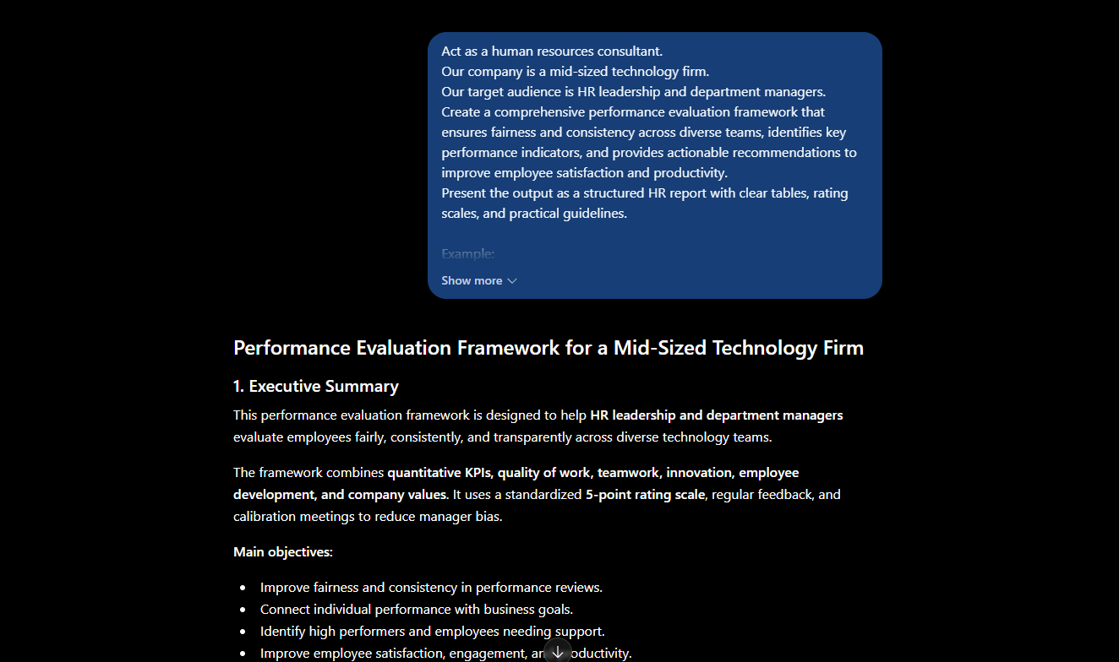

Operational Department

Problem Statement:
The operations department faces challenges in optimizing resource allocation, resulting in underutilized assets and uneven workload distribution across teams.

Basic Prompt:
Company is struggling with supplier raw material problem so hoe to solve this problem with better negotiation power.

Output:
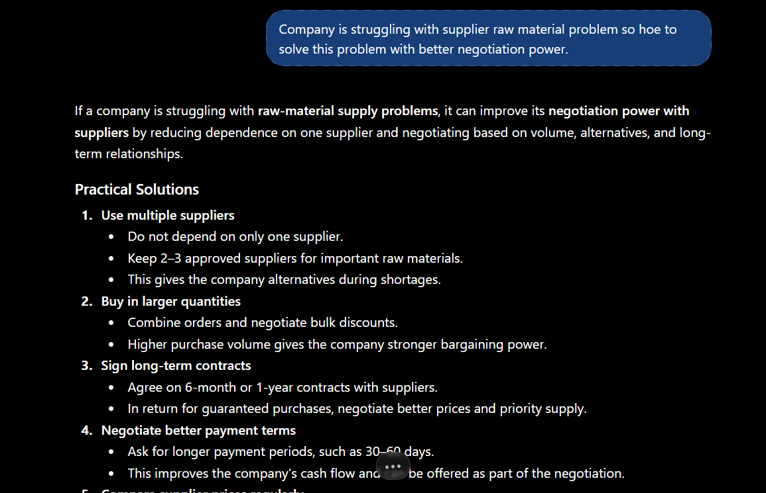

Improved Prompt (Type 1):
Act as a supply chain and procurement strategist. Our company is a mid-sized manufacturing firm. Our target audience is the operations leadership team and procurement managers. Create a supplier negotiation strategy that addresses raw material shortages, strengthens bargaining power, and ensures cost-effective and reliable supply. Present the output as a structured operations report with clear tables, negotiation tactics, risk analysis, and actionable recommendations.

Output:
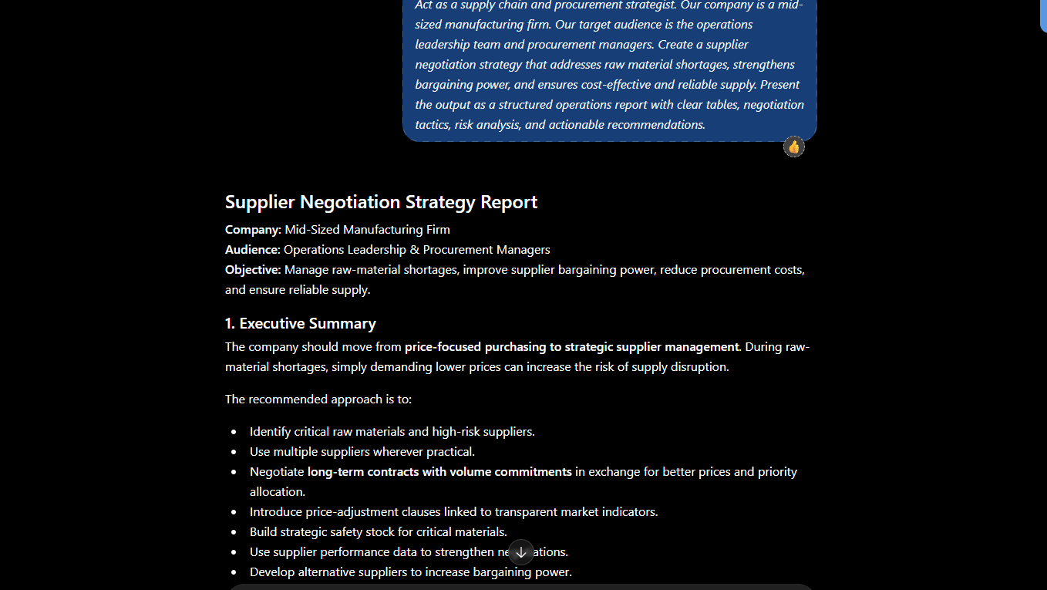

Improved Prompt (Type 2):
Act as a supply chain and procurement strategist. Our company is a mid-sized manufacturing firm. Our target audience is the operations leadership team and procurement managers. Create a supplier negotiation strategy that addresses raw material shortages, strengthens bargaining power, and ensures cost-effective and reliable supply.
Present the output as a structured operations report with clear tables, negotiation tactics, risk analysis, and actionable recommendations.

Example:
Input: "Develop a supplier negotiation strategy for Toyota’s steel procurement."
Output: "Toyota strengthened bargaining power by consolidating supplier contracts, leveraging long-term purchase commitments, and diversifying sourcing regions. Risk analysis highlighted dependency on a single supplier, mitigated through dual sourcing agreements."

Now, using the same style, generate a supplier negotiation strategy for our company’s raw material challenges.

Output:
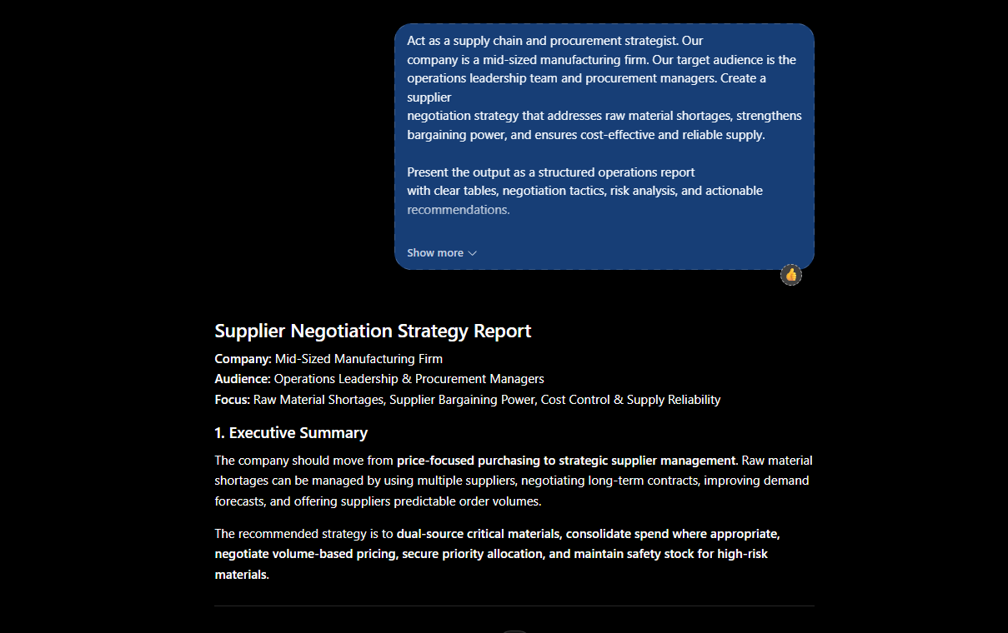

Marketing Department

Problem Statement:
The marketing department struggles to build strong brand awareness in competitive markets, resulting in limited customer recognition and weaker market positioning.

Basic Prompt:
Company is struggling with Low brand awareness so how to fix this?

Output:
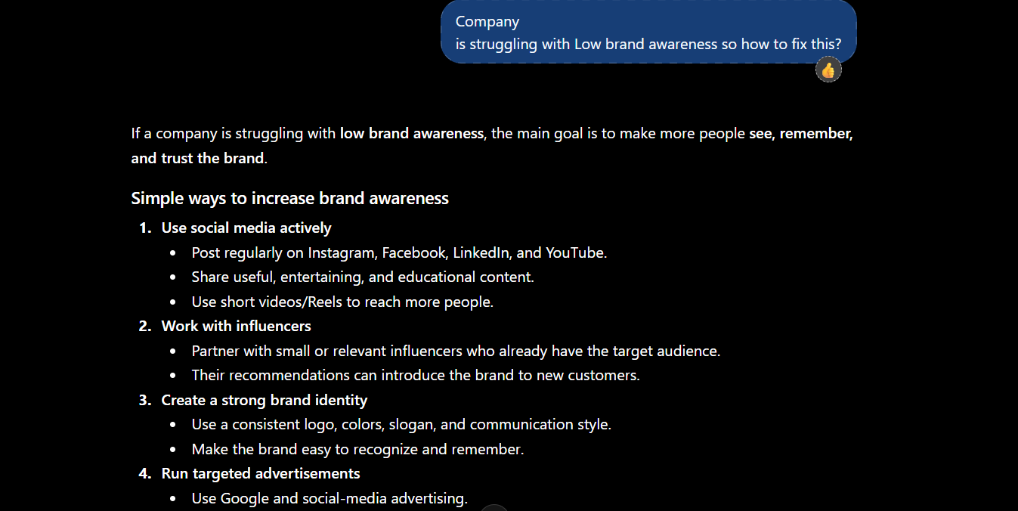

Improved Prompt (Type 1):
Act as a marketing strategist. Our company is a mid-sized consumer goods firm. Our target audience is the marketing leadership team and senior management. Create a brand awareness strategy that strengthens market positioning, improves customer recognition, and leverages both digital and offline campaigns. Present the output as a structured marketing report with clear tables, campaign ideas, KPIs, and actionable recommendations.

Output:
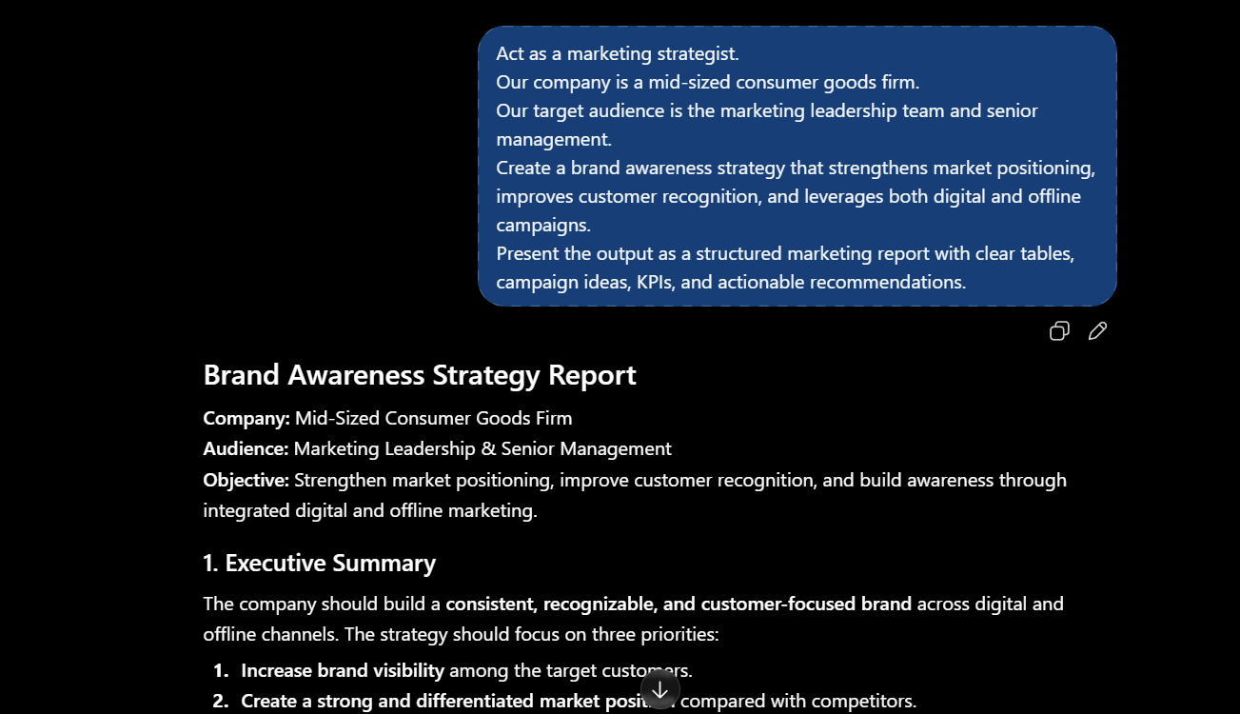

Improved Prompt (Type 2):
Act as a marketing strategist. Our company is a mid-sized consumer goods firm. Our target audience is the marketing leadership team and senior management. Create a brand awareness strategy that strengthens market positioning, improves customer recognition, and leverages digital and offline campaigns. Present the output as a structured marketing report with clear tables, campaign ideas, KPIs, and actionable recommendations.

Example:
Input: "Develop a brand awareness strategy for Coca-Cola in emerging markets."
Output: "Coca-Cola increased brand visibility through localized campaigns, influencer partnerships, and community events. KPIs included social media reach, brand recall surveys, and sales uplift in targeted regions."

Now, using the same style, generate a brand awareness strategy for our company.

Output:
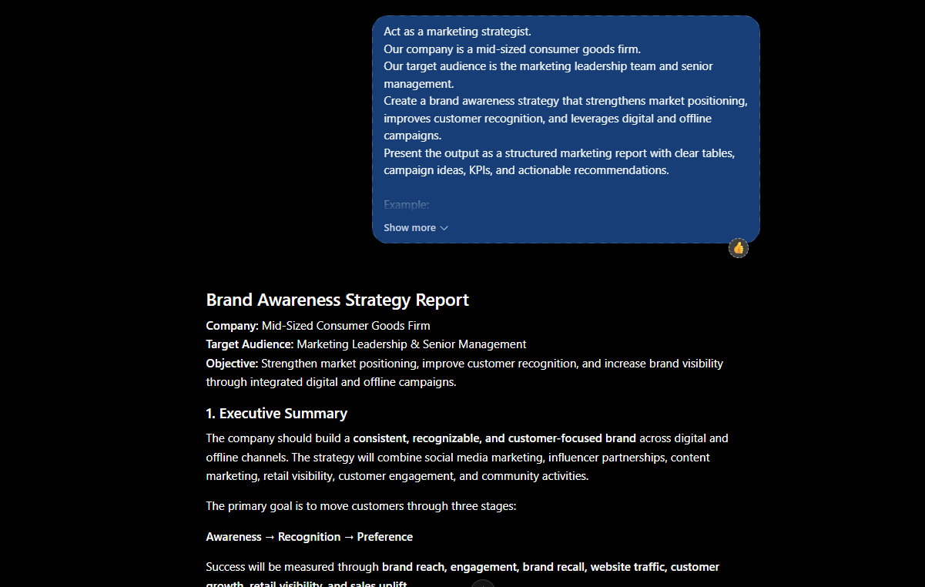

Claude

Finance Department

Problem:
The finance department struggles to accurately forecast budgets due to fluctuating expenses and unpredictable revenue streams.

Basic Prompt:
My finance department is struggling in predicting the expenses and revenue steam what to do?

Output:
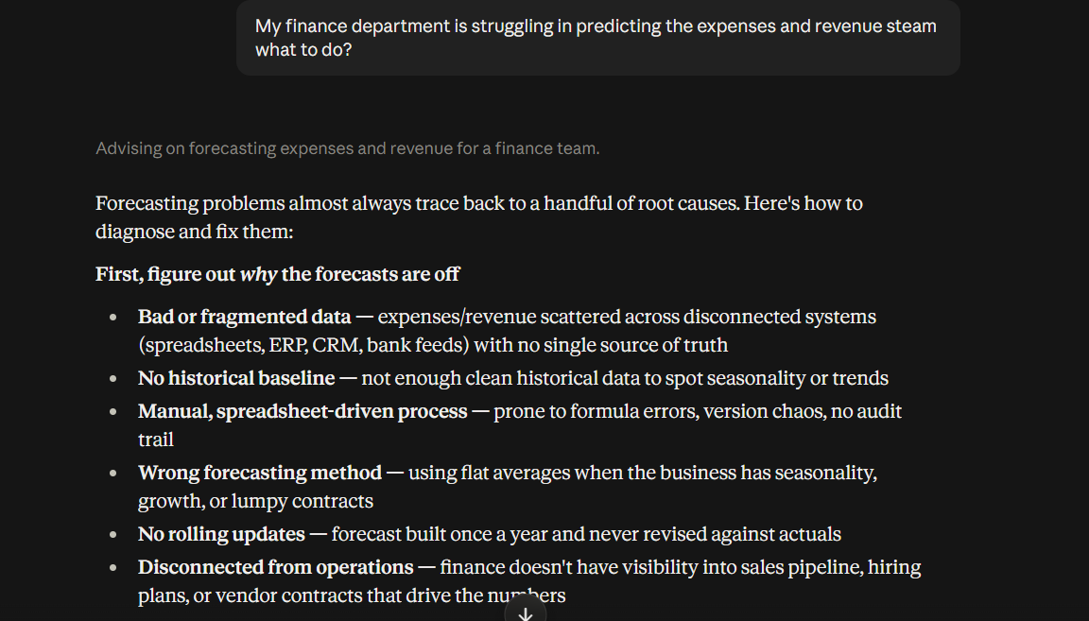

Improved Prompt (Type 1):
Act as a financial analyst. Our company is a mid-sized retail firm. Our target audience is internal management and stakeholders. Create a detailed expense and revenue forecasting report using historical financial data, seasonal trends, and market growth indicators. Present the output as a structured business report with clear tables, charts, and actionable recommendations.

Output:
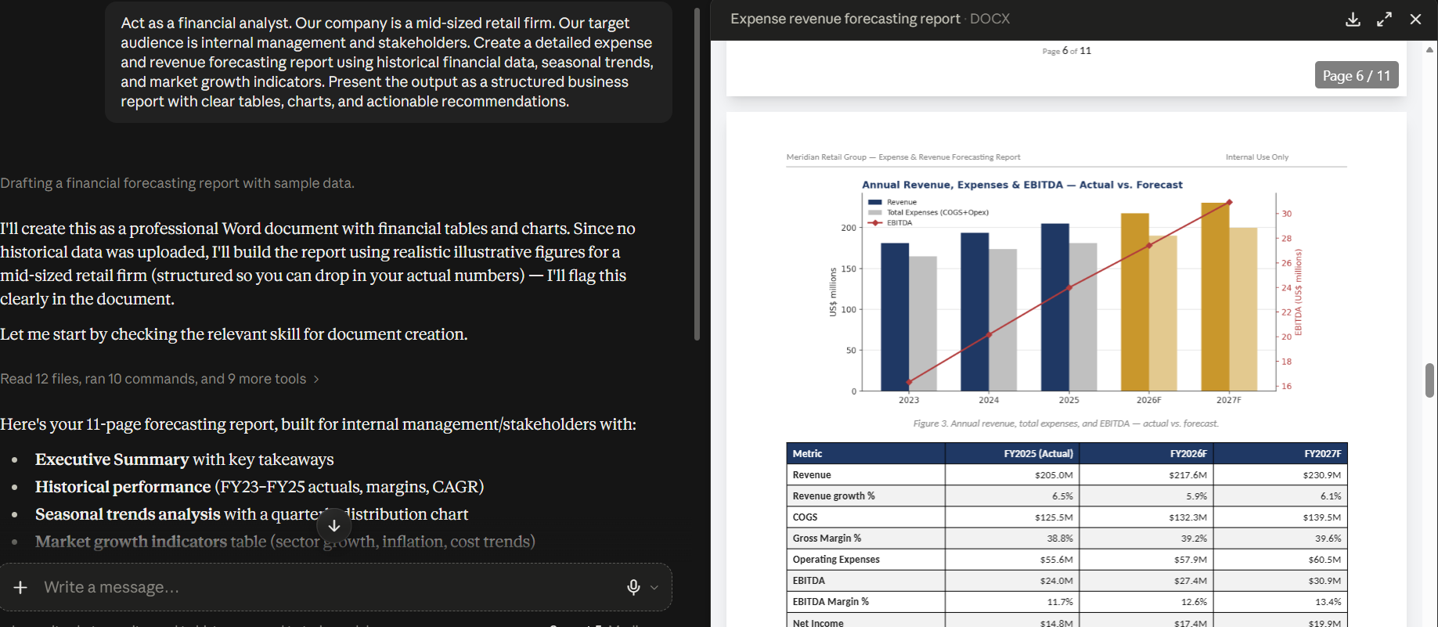

Improved Prompt (Type 2):
Act as a financial analyst. Our company is a mid-sized retail firm. Our target audience is internal management and stakeholders. Create a detailed expense and revenue forecasting report using historical financial data, seasonal trends, and market growth indicators. Present the output as a structured business report with clear tables, charts, and actionable recommendations.

Example:
Forecast revenue of JPMorgan in Q2 based on market growth and historical performance.
Now, using the same style, generate a forecast for our company’s expenses and revenue streams for the upcoming financial year. Take synthetic numbers.

Output:
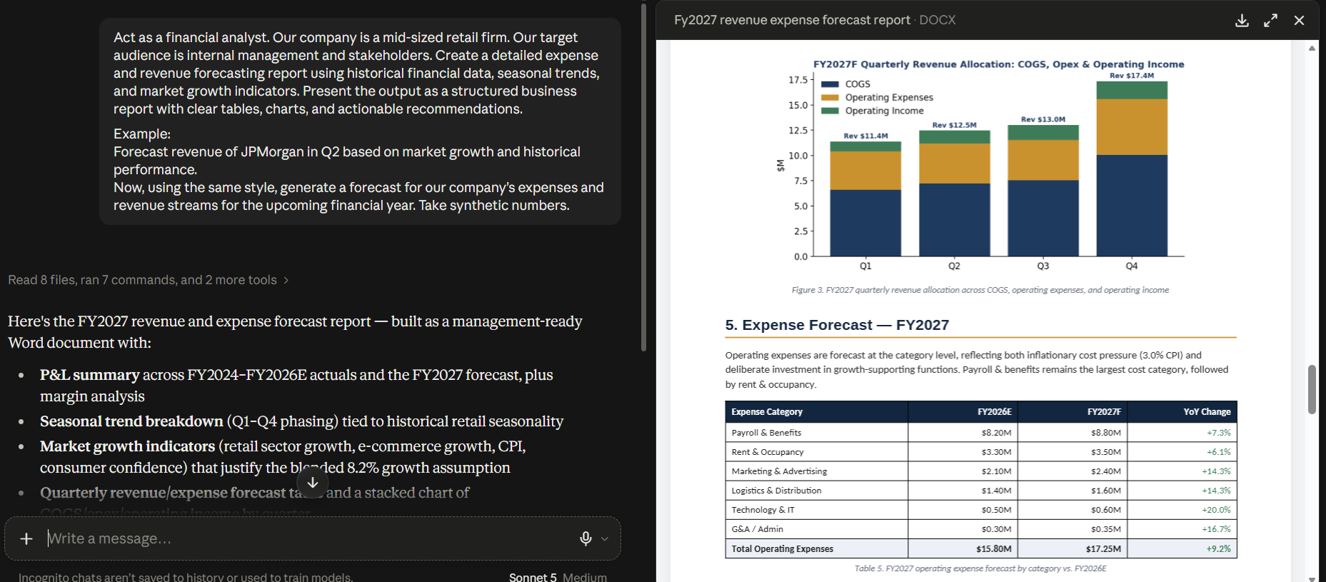
Operational Department

Problem Statement:
The operations department faces challenges in optimizing resource allocation, resulting in underutilized assets and uneven workload distribution across teams.

Basic Prompt:
Company is struggling with supplier raw material problem so hoe to solve this problem with better negotiation power.

Output:
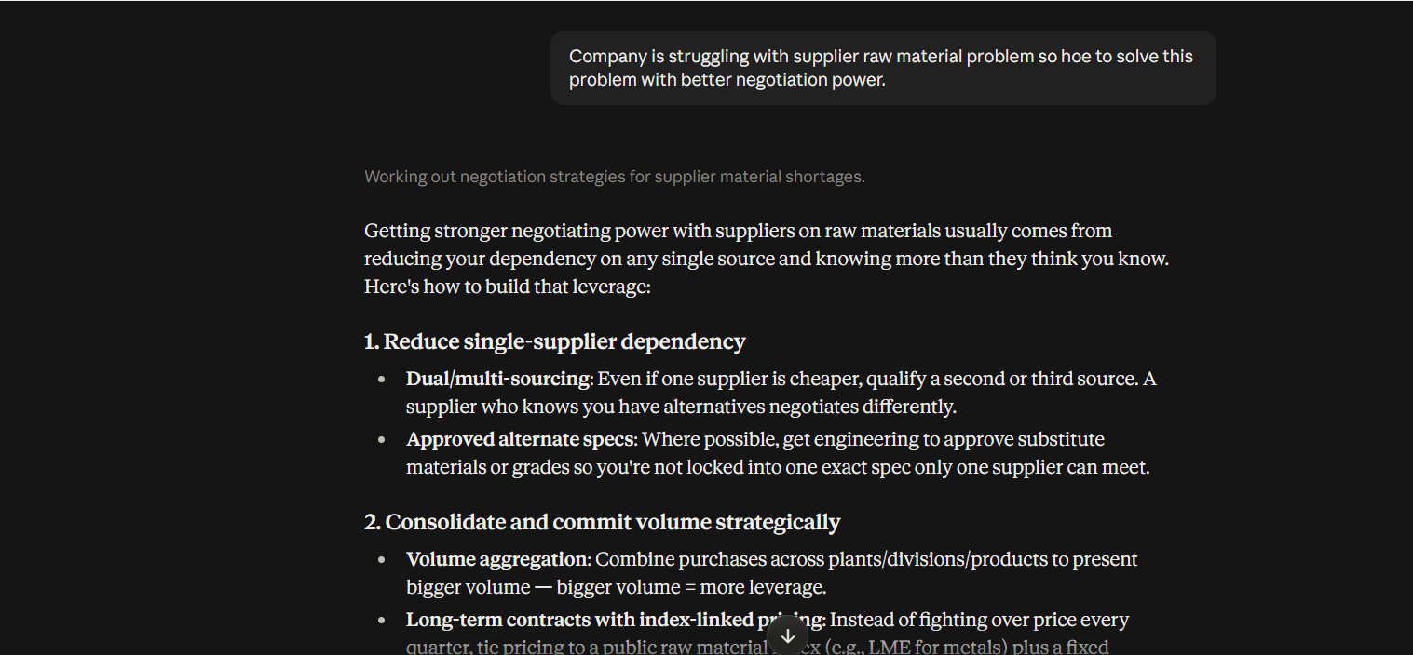

Improved Prompt (Type 1):
Act as a supply chain and procurement strategist. Our company is a mid-sized manufacturing firm. Our target audience is the operations leadership team and procurement managers. Create a supplier negotiation strategy that addresses raw material shortages, strengthens bargaining power, and ensures cost-effective and reliable supply. Present the output as a structured operations report with clear tables, negotiation tactics, risk analysis, and actionable recommendations.

Output:
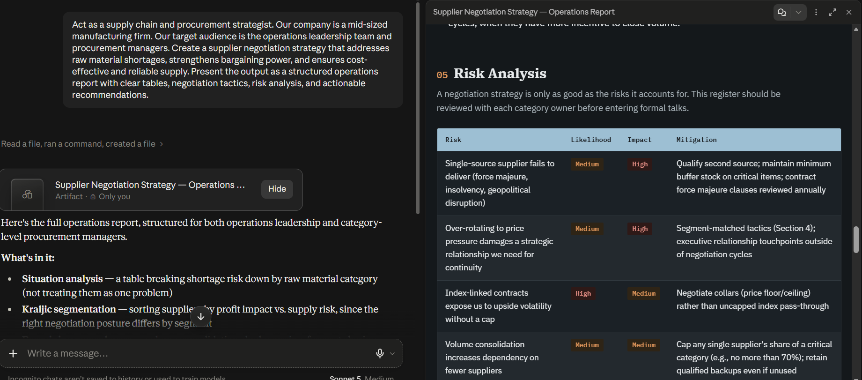

Improved Prompt (Type 2):
Act as a supply chain and procurement strategist. Our company is a mid-sized manufacturing firm. Our target audience is the operations leadership team and procurement managers. Create a supplier negotiation strategy that addresses raw material shortages, strengthens bargaining power, and ensures cost-effective and reliable supply.
Present the output as a structured operations report with clear tables, negotiation tactics, risk analysis, and actionable recommendations.

Example:
Input: "Develop a supplier negotiation strategy for Toyota’s steel procurement."
Output: "Toyota strengthened bargaining power by consolidating supplier contracts, leveraging long-term purchase commitments, and diversifying sourcing regions. Risk analysis highlighted dependency on a single supplier, mitigated through dual sourcing agreements."

Now, using the same style, generate a supplier negotiation strategy for our company’s raw material challenges.

Output:
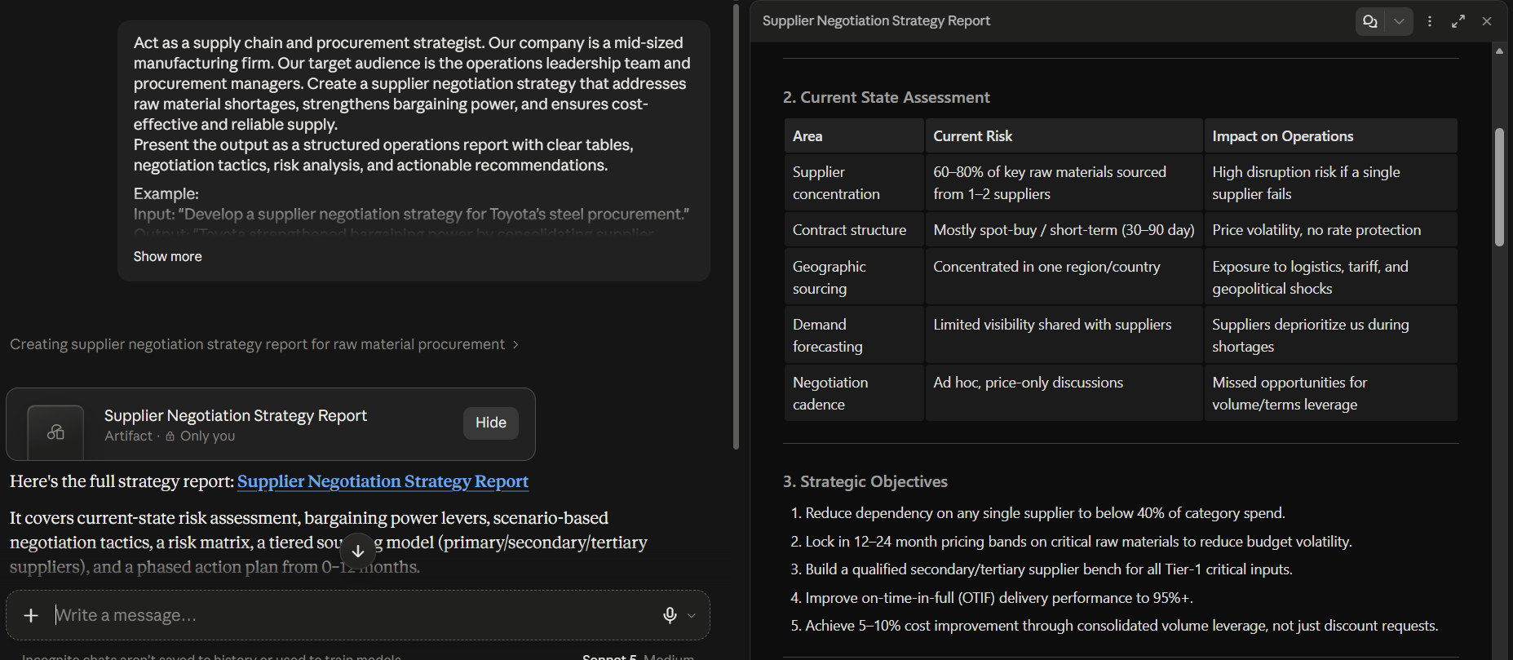

HR Department

Problem Statement:
The HR department finds it difficult to conduct fair and consistent performance evaluations across diverse teams, resulting in employee dissatisfaction and reduced productivity.

Basic Prompt:
Company is facing problem to tracking the work of the employe which is creating the problem. How to solve?

Output:
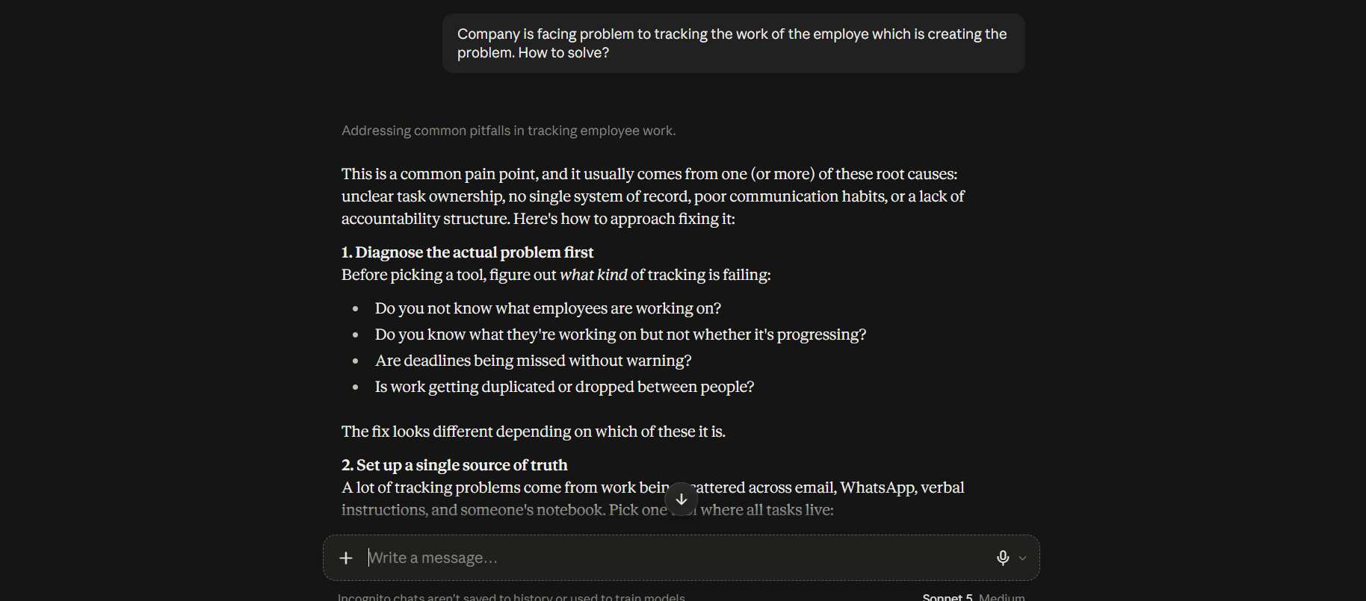

Improved Prompt (Type 1):
Act as a human resources consultant. Our company is a mid-sized technology firm. Our target audience is HR leadership and department managers. Create a comprehensive performance evaluation framework that ensures fairness and consistency across diverse teams, identifies key performance indicators, and provides actionable recommendations to improve employee satisfaction and productivity. Present the output as a structured HR report with clear tables, rating scales, and practical guidelines.

Output:
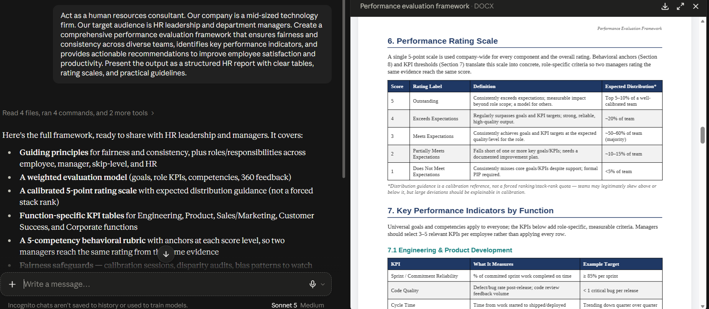

Improved Prompt (Type 2):
Act as a human resources consultant. Our company is a mid-sized technology firm. Our target audience is HR leadership and department managers. Create a comprehensive performance evaluation framework that ensures fairness and consistency across diverse teams, identifies key performance indicators, and provides actionable recommendations to improve employee satisfaction and productivity. Present the output as a structured HR report with clear tables, rating scales, and practical guidelines.

Example:
Input: "Design a performance evaluation framework for Google’s engineering teams."
Output: "Framework includes standardized KPIs such as code quality, project delivery timelines, collaboration scores, and innovation metrics. Evaluation uses a 5-point rating scale with clear guidelines to ensure fairness across teams."

Now, using the same style, generate a performance evaluation framework for our company.

Output:
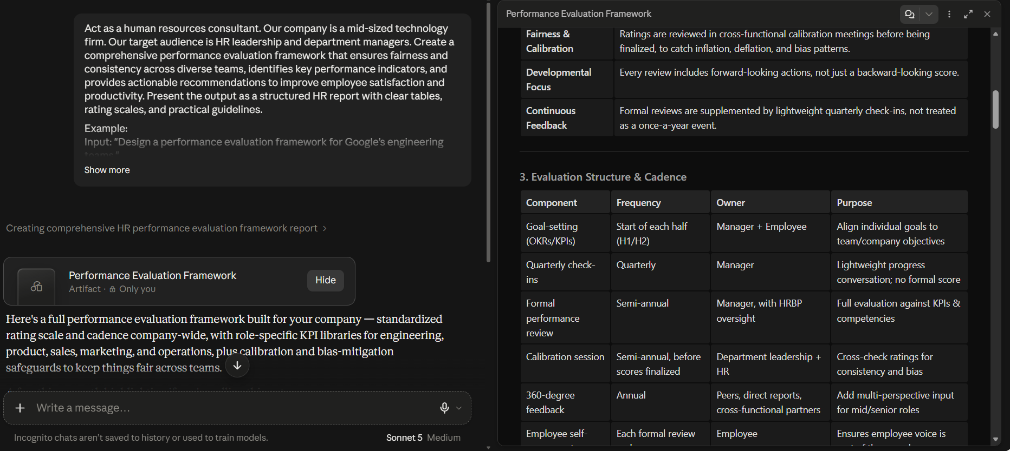

Marketing Department

Problem Statement:
The marketing department struggles to build strong brand awareness in competitive markets, resulting in limited customer recognition and weaker market positioning.

Basic Prompt:
Company is struggling with Low brand awareness so how to fix this?

Output:
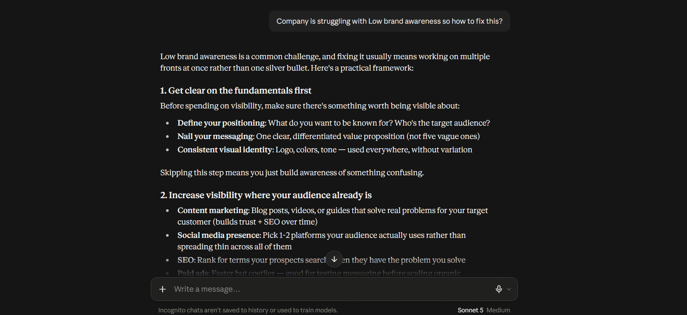

Improved Prompt (Type 1):
Act as a marketing strategist. Our company is a mid-sized consumer goods firm. Our target audience is the marketing leadership team and senior management. Create a brand awareness strategy that strengthens market positioning, improves customer recognition, and leverages both digital and offline campaigns. Present the output as a structured marketing report with clear tables, campaign ideas, KPIs, and actionable recommendations.

Output:
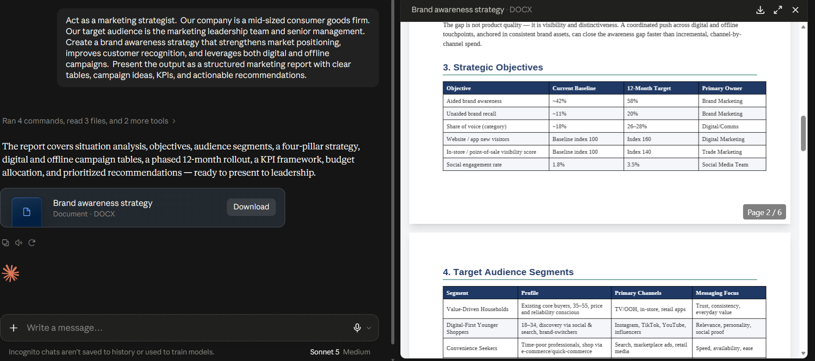

Improved Prompt (Type 2):
Act as a marketing strategist. Our company is a mid-sized consumer goods firm. Our target audience is the marketing leadership team and senior management. Create a brand awareness strategy that strengthens market positioning, improves customer recognition, and leverages digital and offline campaigns. Present the output as a structured marketing report with clear tables, campaign ideas, KPIs, and actionable recommendations.

Example:
Input: "Develop a brand awareness strategy for Coca-Cola in emerging markets."
Output: "Coca-Cola increased brand visibility through localized campaigns, influencer partnerships, and community events. KPIs included social media reach, brand recall surveys, and sales uplift in targeted regions."

Now, using the same style, generate a brand awareness strategy for our company.

Output:
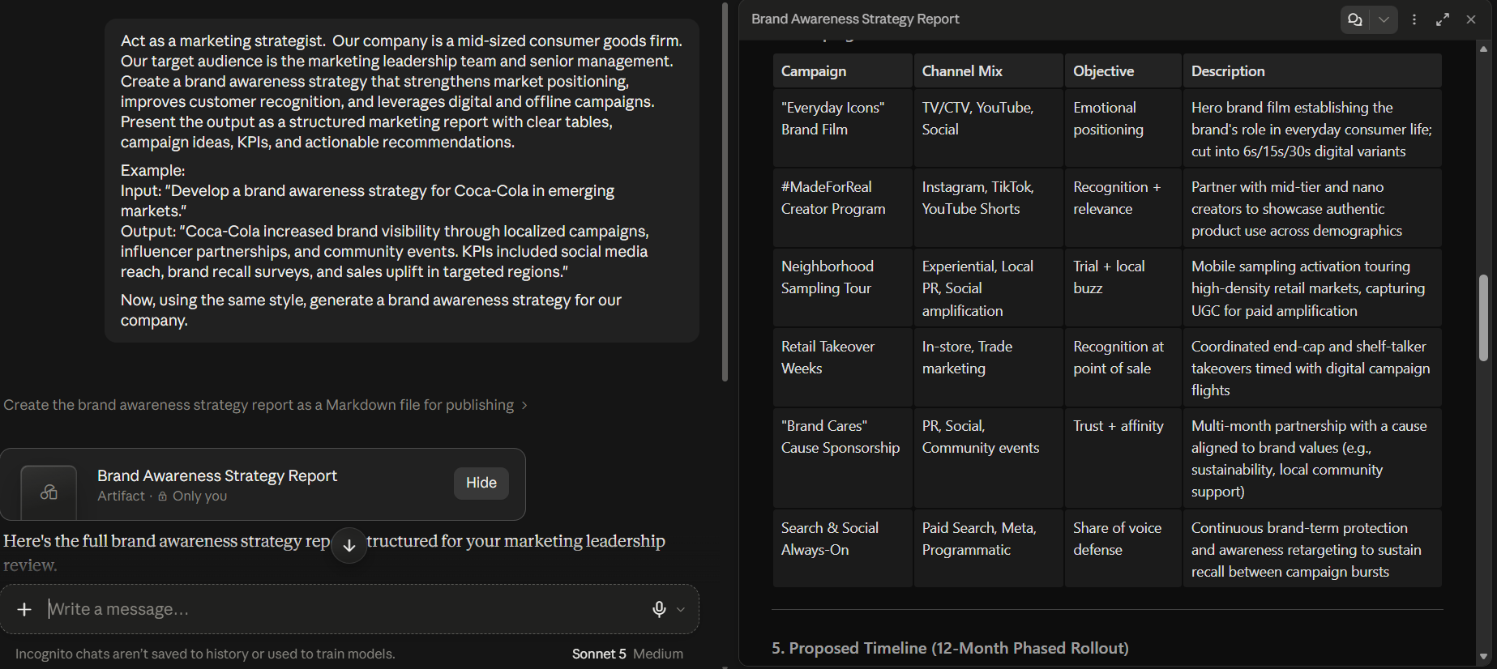

Perplexity

Finance Department

Problem Statement:
The finance department struggles to accurately forecast budgets due to fluctuating expenses and unpredictable revenue streams.

Basic Prompt:
My finance department is struggling in predicting the expenses and revenue steam what to do?

Output:
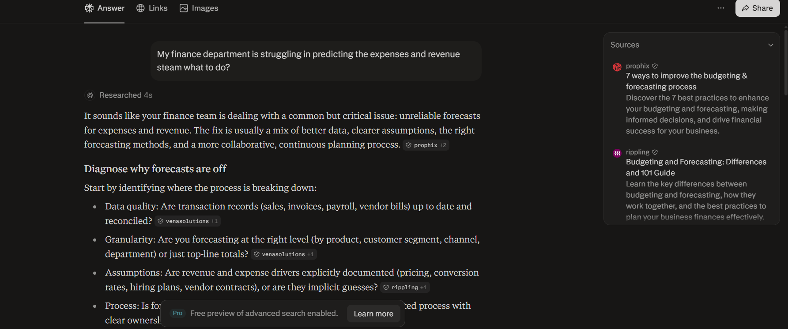

Improved Prompt (Type 1):
Act as a financial analyst. Our company is a mid-sized retail firm. Our target audience is internal management and stakeholders. Create a detailed expense and revenue forecasting report using historical financial data, seasonal trends, and market growth indicators. Present the output as a structured business report with clear tables, charts, and actionable recommendations.

Output:
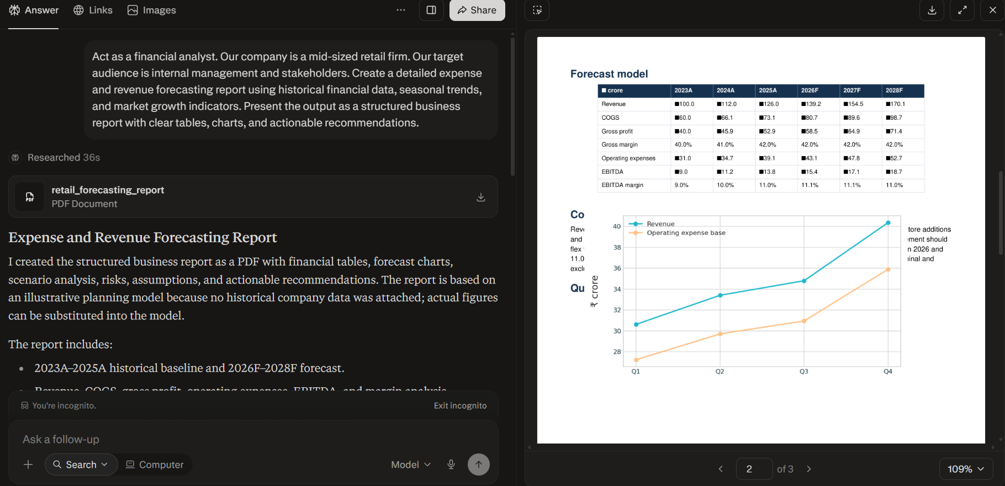

Improved Prompt (Type 2):
Act as a financial analyst. Our company is a mid-sized retail firm. Our target audience is internal management and stakeholders. Create a detailed expense and revenue forecasting report using historical financial data, seasonal trends, and market growth indicators. Present the output as a structured business report with clear tables, charts, and actionable recommendations.

Example:
Forecast revenue of JPMorgan in Q2 based on market growth and historical performance.
Now, using the same style, generate a forecast for our company’s expenses and revenue streams for the upcoming financial year. Take synthetic numbers.

Output:
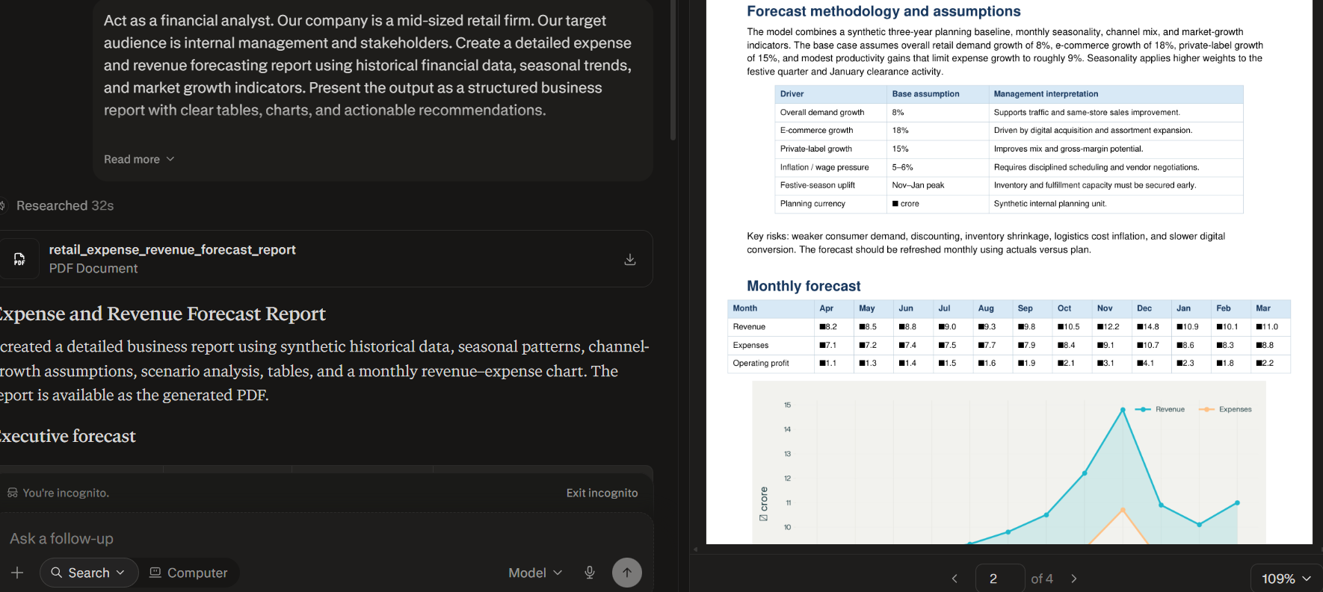

Operational Department

Problem Statement:
The operations department faces challenges in optimizing resource allocation, resulting in underutilized assets and uneven workload distribution across teams.

Basic Prompt:
Company is struggling with supplier raw material problem so hoe to solve this problem with better negotiation power.

Output:
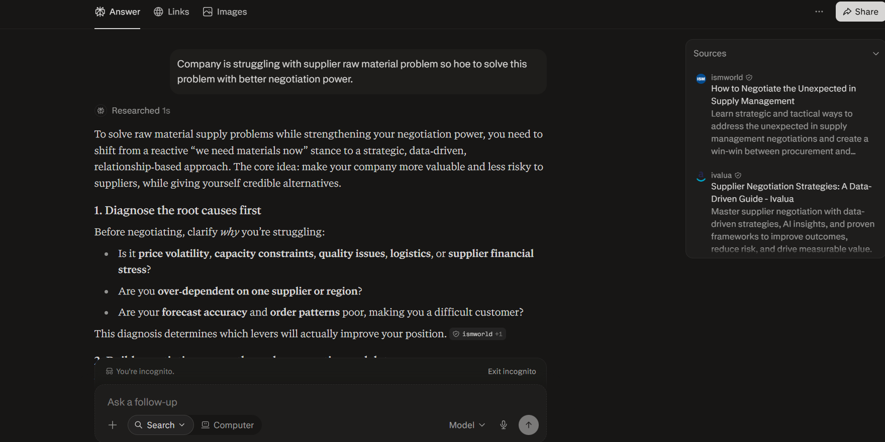

Improved Prompt (Type 1):
Act as a supply chain and procurement strategist. Our company is a mid-sized manufacturing firm. Our target audience is the operations leadership team and procurement managers. Create a supplier negotiation strategy that addresses raw material shortages, strengthens bargaining power, and ensures cost-effective and reliable supply. Present the output as a structured operations report with clear tables, negotiation tactics, risk analysis, and actionable recommendations.

Output:
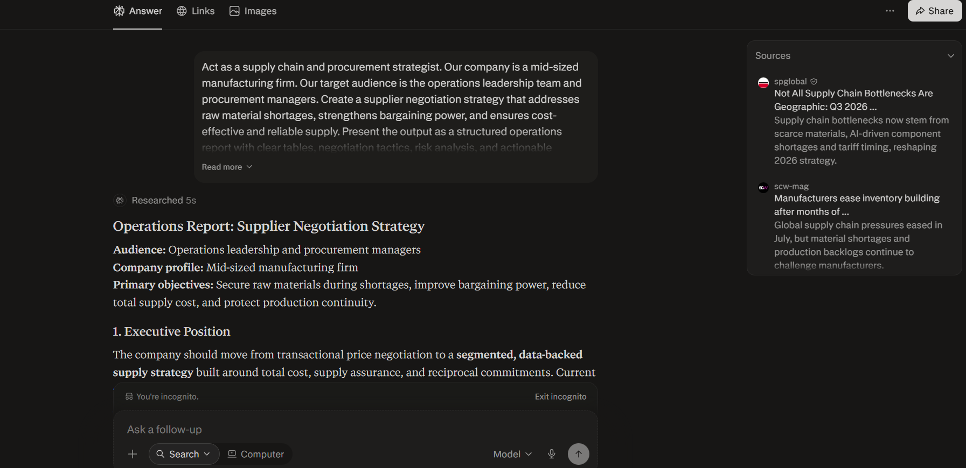

Improved Prompt (Type 2):
Act as a supply chain and procurement strategist. Our company is a mid-sized manufacturing firm. Our target audience is the operations leadership team and procurement managers. Create a supplier negotiation strategy that addresses raw material shortages, strengthens bargaining power, and ensures cost-effective and reliable supply.
Present the output as a structured operations report with clear tables, negotiation tactics, risk analysis, and actionable recommendations.

Example:
Input: "Develop a supplier negotiation strategy for Toyota’s steel procurement."
Output: "Toyota strengthened bargaining power by consolidating supplier contracts, leveraging long-term purchase commitments, and diversifying sourcing regions. Risk analysis highlighted dependency on a single supplier, mitigated through dual sourcing agreements."

Now, using the same style, generate a supplier negotiation strategy for our company’s raw material challenges.

Output:
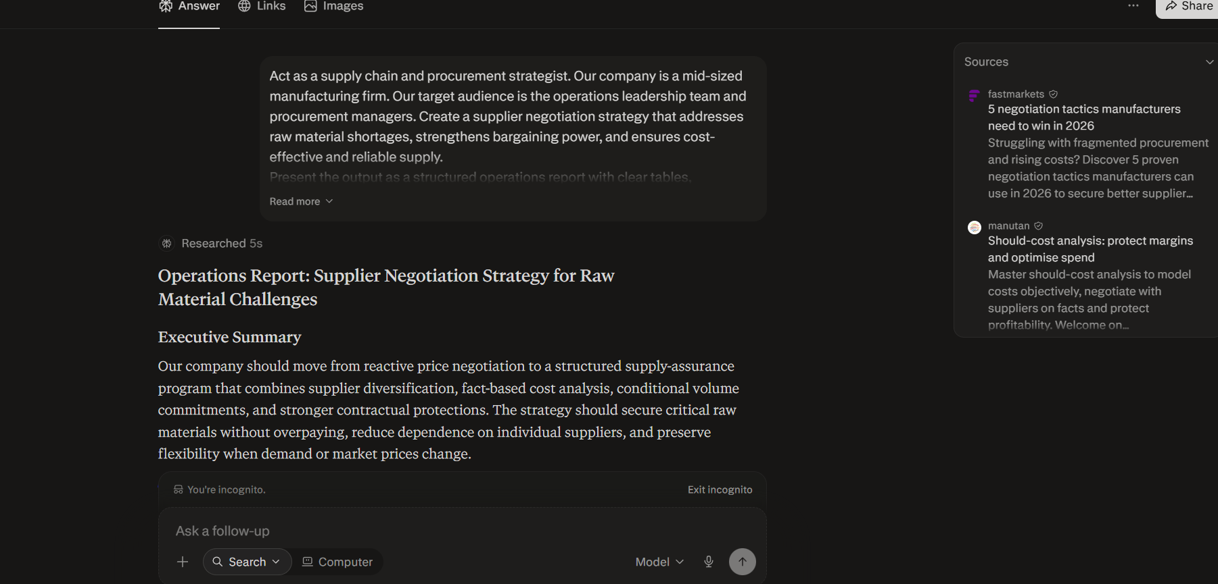

HR Department

Problem Statement:
The HR department finds it difficult to conduct fair and consistent performance evaluations across diverse teams, resulting in employee dissatisfaction and reduced productivity.

Basic Prompt:
Company is facing problem to tracking the work of the employe which is creating the problem. How to solve?

Output:
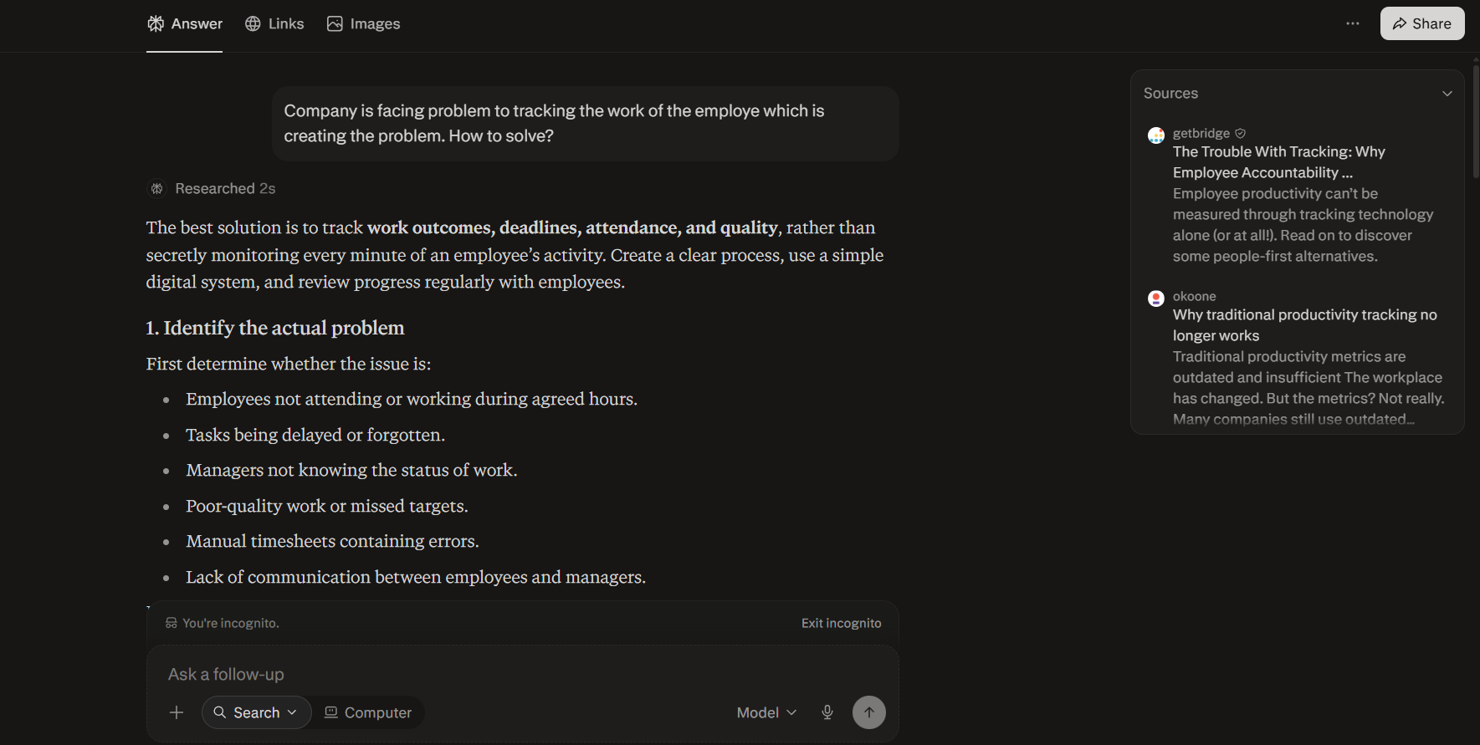

Improved Prompt (Type 1):
Act as a human resources consultant. Our company is a mid-sized technology firm. Our target audience is HR leadership and department managers. Create a comprehensive performance evaluation framework that ensures fairness and consistency across diverse teams, identifies key performance indicators, and provides actionable recommendations to improve employee satisfaction and productivity. Present the output as a structured HR report with clear tables, rating scales, and practical guidelines.

Output:
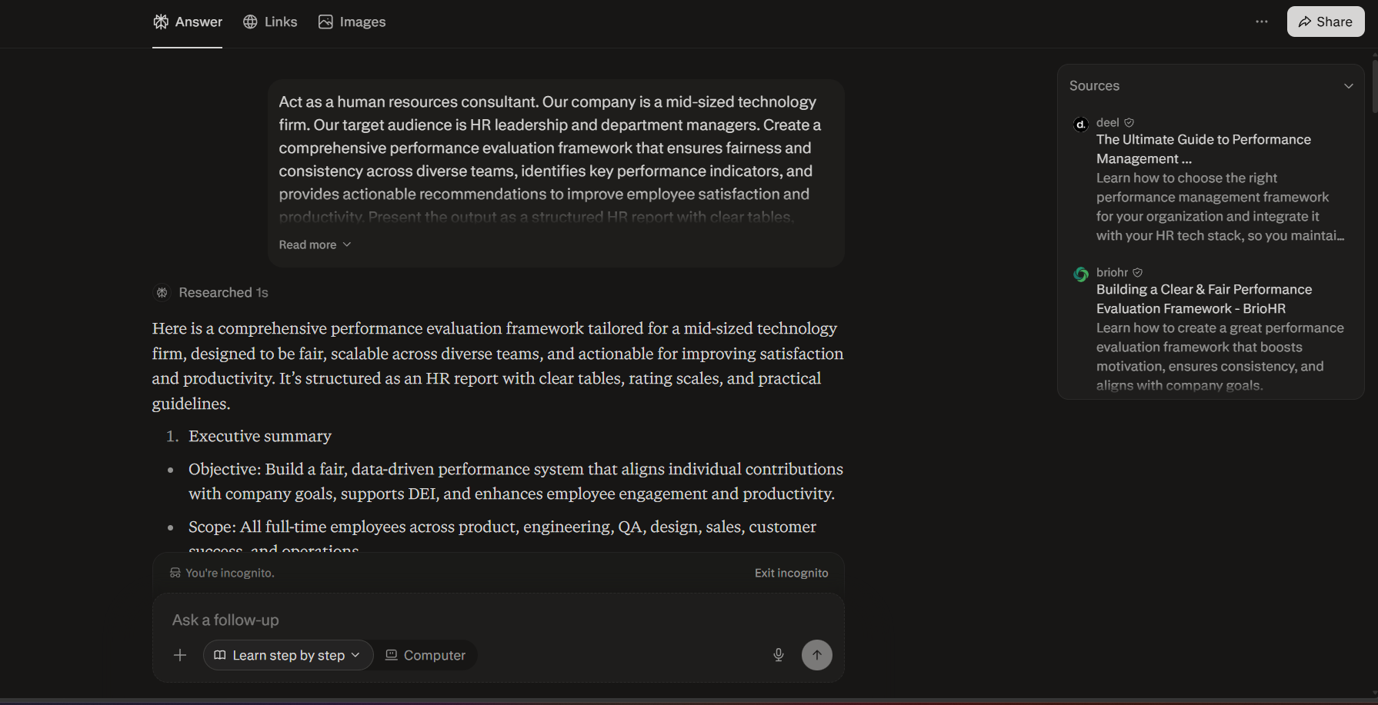

Improved Prompt (Type 2):
Act as a human resources consultant. Our company is a mid-sized technology firm. Our target audience is HR leadership and department managers. Create a comprehensive performance evaluation framework that ensures fairness and consistency across diverse teams, identifies key performance indicators, and provides actionable recommendations to improve employee satisfaction and productivity. Present the output as a structured HR report with clear tables, rating scales, and practical guidelines.

Example:
Input: "Design a performance evaluation framework for Google’s engineering teams."
Output: "Framework includes standardized KPIs such as code quality, project delivery timelines, collaboration scores, and innovation metrics. Evaluation uses a 5-point rating scale with clear guidelines to ensure fairness across teams."

Now, using the same style, generate a performance evaluation framework for our company.

Output:
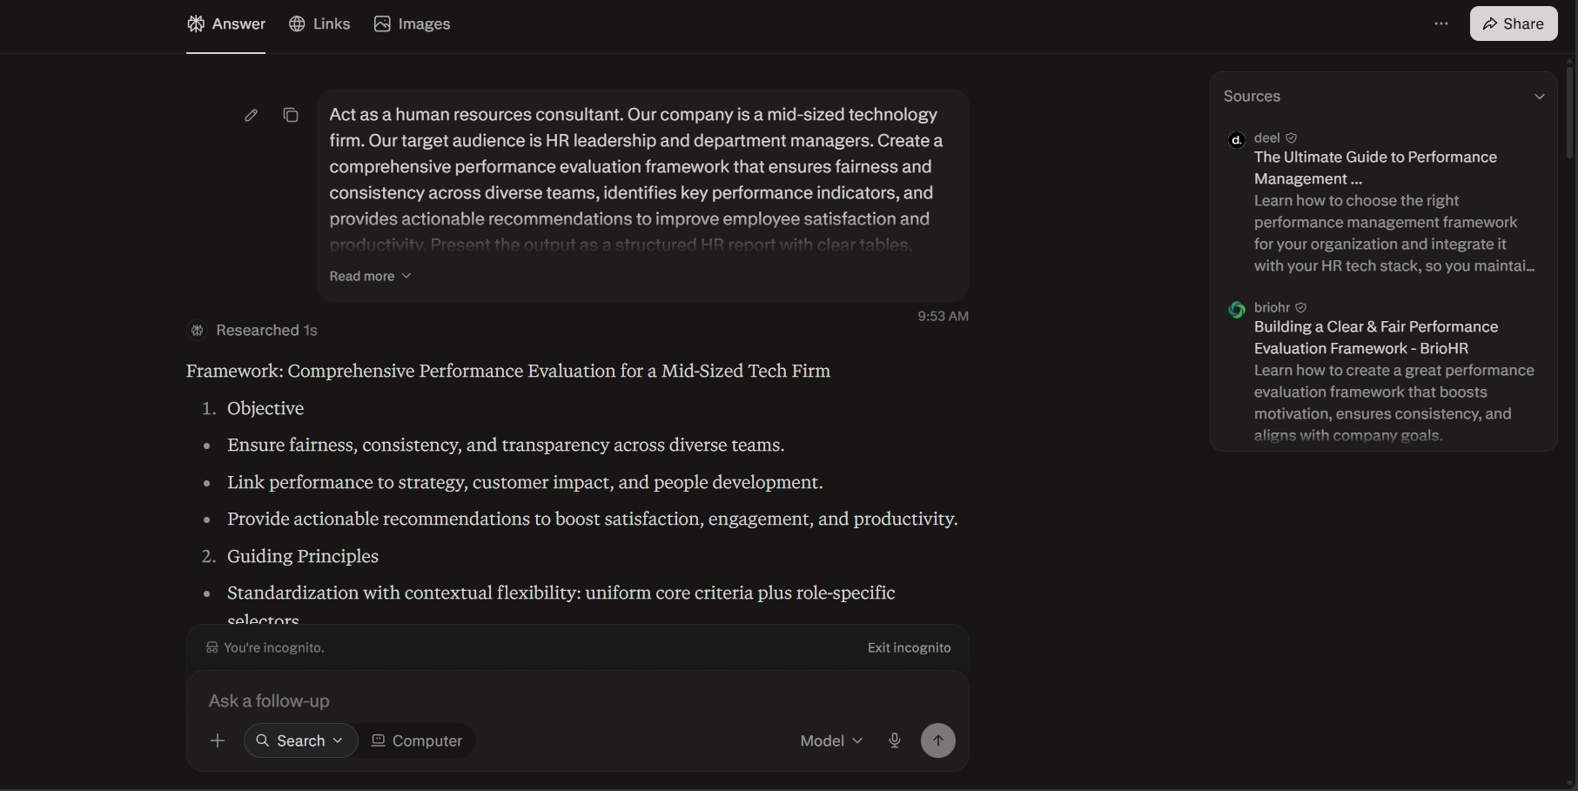

Marketing Department

Problem Statement:
The marketing department struggles to build strong brand awareness in competitive markets, resulting in limited customer recognition and weaker market positioning.

Basic Prompt:
Company is struggling with Low brand awareness so how to fix this?

Output:
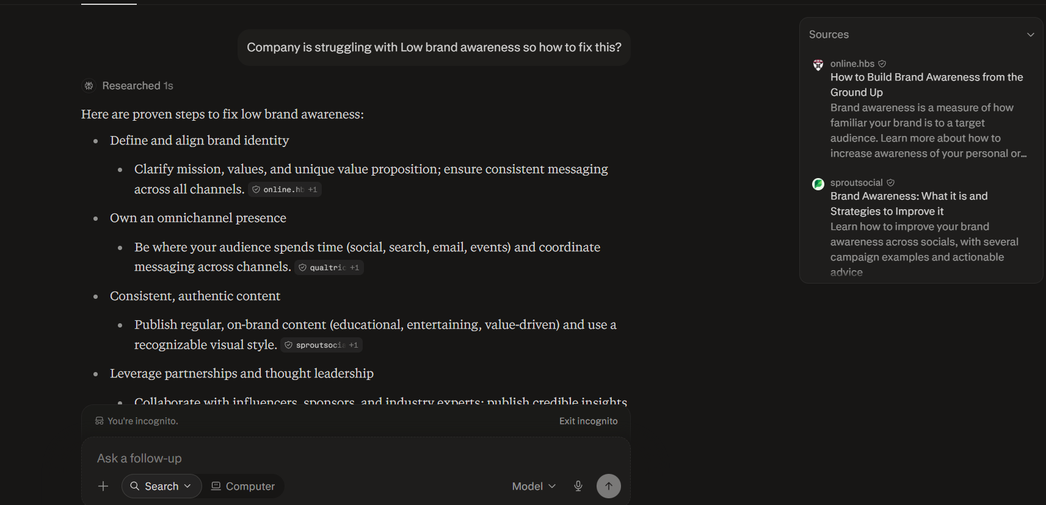

Improved Prompt (Type 1):
Act as a marketing strategist. Our company is a mid-sized consumer goods firm. Our target audience is the marketing leadership team and senior management. Create a brand awareness strategy that strengthens market positioning, improves customer recognition, and leverages both digital and offline campaigns. Present the output as a structured marketing report with clear tables, campaign ideas, KPIs, and actionable recommendations.

Output:
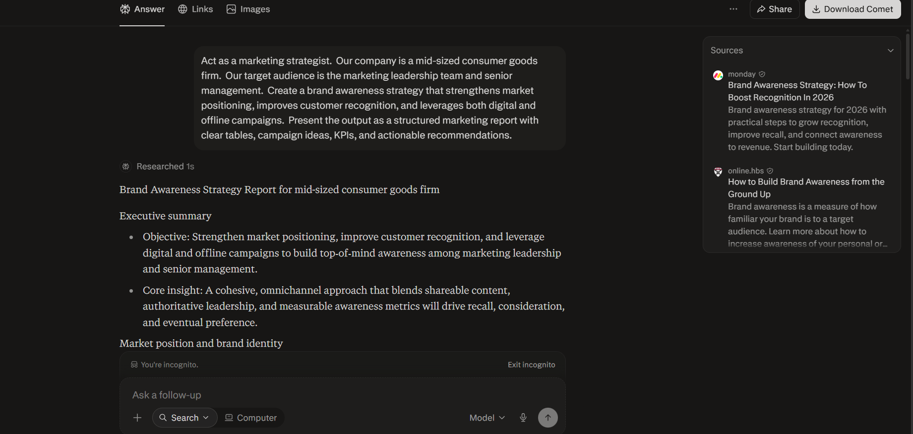

Improved Prompt (Type 2):
Act as a marketing strategist. Our company is a mid-sized consumer goods firm. Our target audience is the marketing leadership team and senior management. Create a brand awareness strategy that strengthens market positioning, improves customer recognition, and leverages digital and offline campaigns. Present the output as a structured marketing report with clear tables, campaign ideas, KPIs, and actionable recommendations.

Example:
Input: "Develop a brand awareness strategy for Coca-Cola in emerging markets."
Output: "Coca-Cola increased brand visibility through localized campaigns, influencer partnerships, and community events. KPIs included social media reach, brand recall surveys, and sales uplift in targeted regions."

Now, using the same style, generate a brand awareness strategy for our company.

Output:
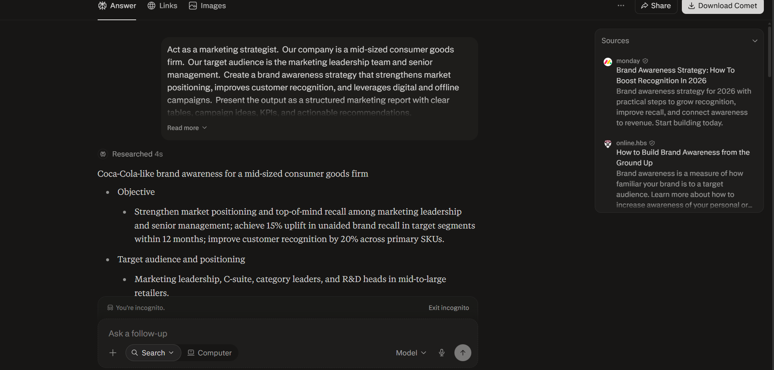
Gemini

Finance Department

Problem Statement:
The finance department struggles to accurately forecast budgets due to fluctuating expenses and unpredictable revenue streams.

Basic Prompt:
My finance department is struggling in predicting the expenses and revenue steam what to do?

Output:
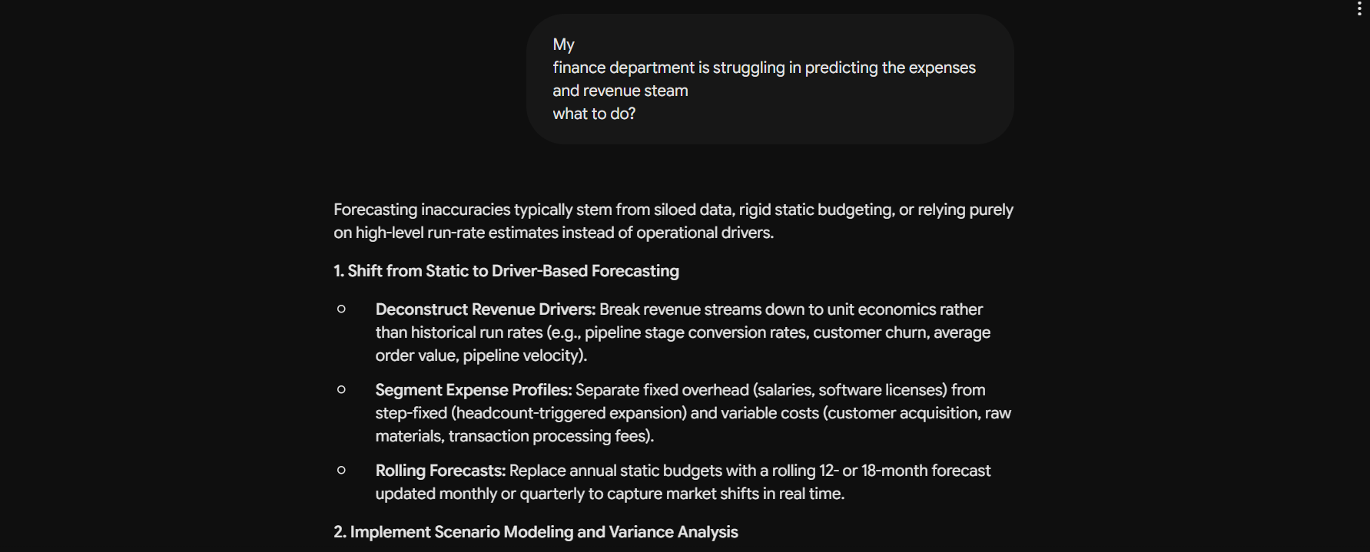

Improved Prompt (Type 1):
Act as a financial analyst. Our company is a mid-sized retail firm. Our target audience is internal management and stakeholders. Create a detailed expense and revenue forecasting report using historical financial data, seasonal trends, and market growth indicators. Present the output as a structured business report with clear tables, charts, and actionable recommendations.

Output:
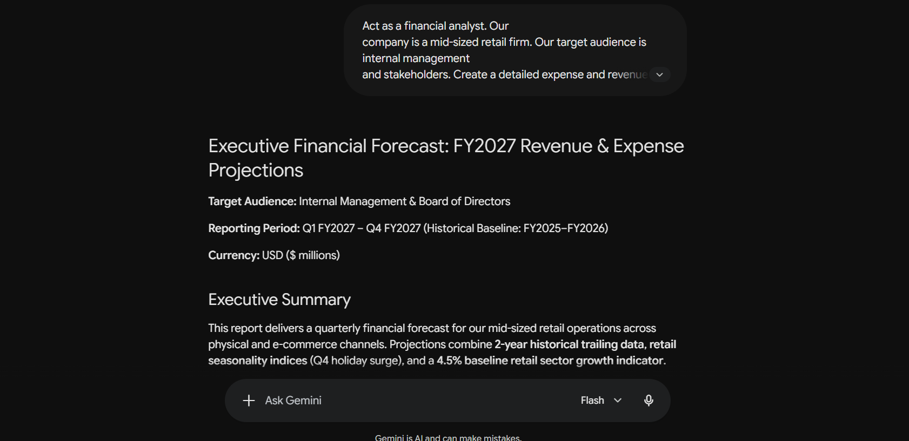

Improved Prompt (Type 2):
Act as a financial analyst. Our company is a mid-sized retail firm. Our target audience is internal management and stakeholders. Create a detailed expense and revenue forecasting report using historical financial data, seasonal trends, and market growth indicators. Present the output as a structured business report with clear tables, charts, and actionable recommendations.

Example:
Forecast revenue of JPMorgan in Q2 based on market growth and historical performance.
Now, using the same style, generate a forecast for our company’s expenses and revenue streams for the upcoming financial year. Take synthetic numbers.

Output:
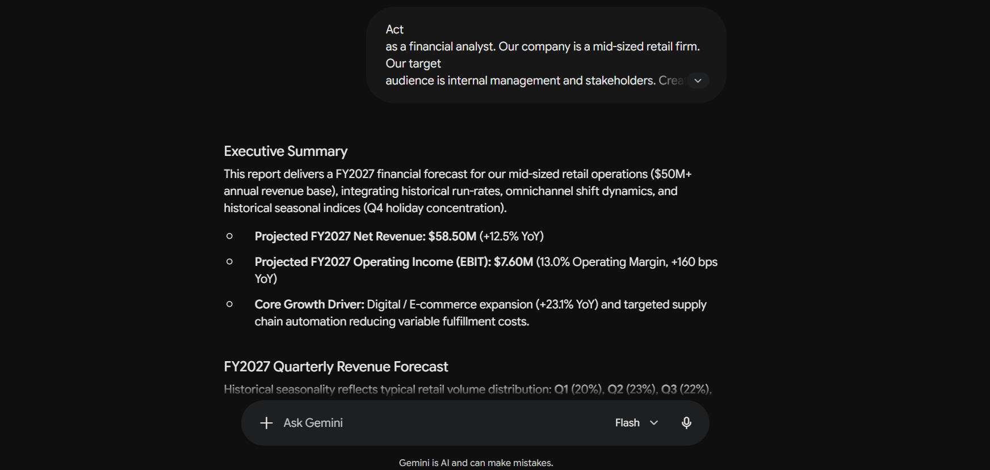

Operational Department

Problem Statement:
The operations department faces challenges in optimizing resource allocation, resulting in underutilized assets and uneven workload distribution across teams.

Basic Prompt:
Company is struggling with supplier raw material problem so hoe to solve this problem with better negotiation power.

Output:
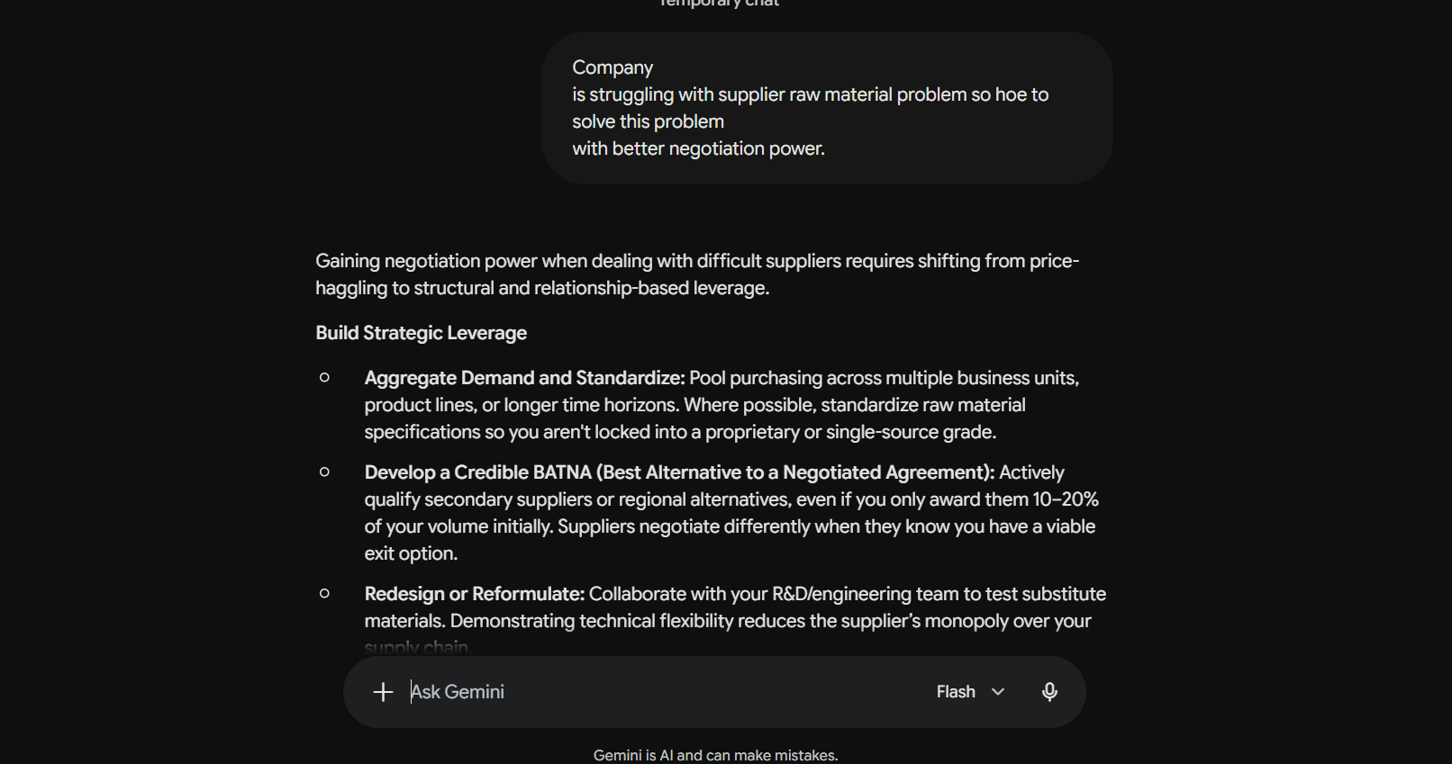

Improved Prompt (Type 1):
Act as a supply chain and procurement strategist. Our company is a mid-sized manufacturing firm. Our target audience is the operations leadership team and procurement managers. Create a supplier negotiation strategy that addresses raw material shortages, strengthens bargaining power, and ensures cost-effective and reliable supply. Present the output as a structured operations report with clear tables, negotiation tactics, risk analysis, and actionable recommendations.

Output:
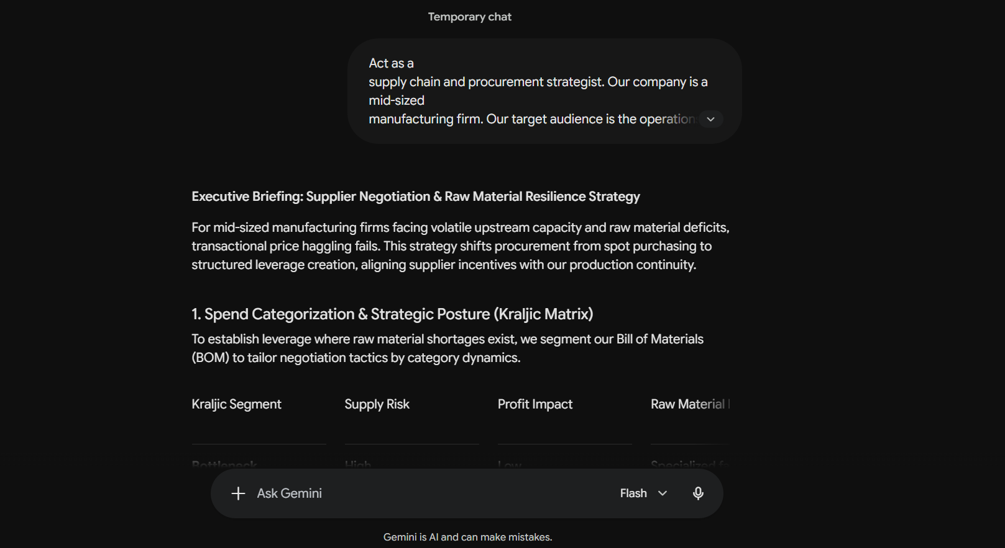

Improved Prompt (Type 2):
Act as a supply chain and procurement strategist. Our company is a mid-sized manufacturing firm. Our target audience is the operations leadership team and procurement managers. Create a supplier negotiation strategy that addresses raw material shortages, strengthens bargaining power, and ensures cost-effective and reliable supply.
Present the output as a structured operations report with clear tables, negotiation tactics, risk analysis, and actionable recommendations.

Example:
Input: "Develop a supplier negotiation strategy for Toyota’s steel procurement."
Output: "Toyota strengthened bargaining power by consolidating supplier contracts, leveraging long-term purchase commitments, and diversifying sourcing regions. Risk analysis highlighted dependency on a single supplier, mitigated through dual sourcing agreements."

Now, using the same style, generate a supplier negotiation strategy for our company’s raw material challenges.

Output:
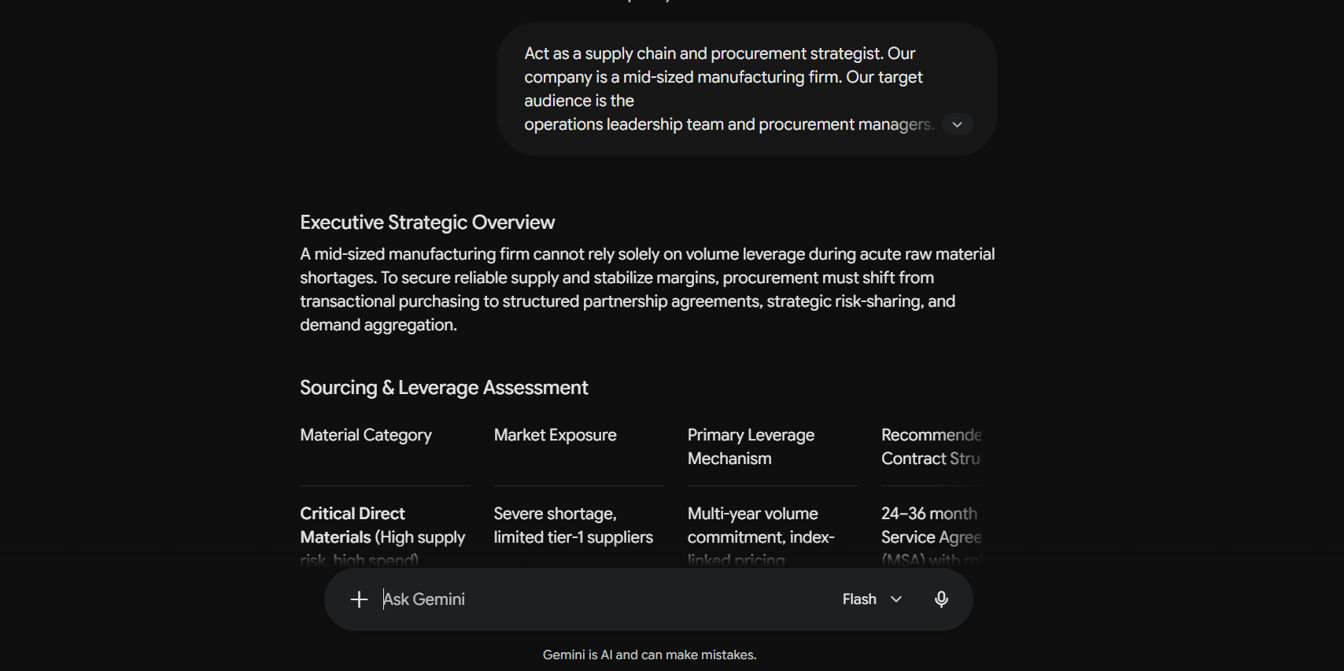

HR Department

Problem Statement:
The HR department finds it difficult to conduct fair and consistent performance evaluations across diverse teams, resulting in employee dissatisfaction and reduced productivity.

Basic Prompt:
Company is facing problem to tracking the work of the employe which is creating the problem. How to solve?

Output:
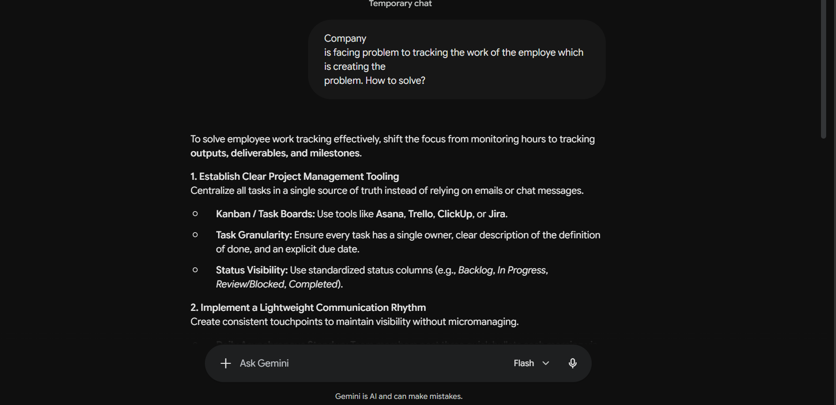

Improved Prompt (Type 1):
Act as a human resources consultant. Our company is a mid-sized technology firm. Our target audience is HR leadership and department managers. Create a comprehensive performance evaluation framework that ensures fairness and consistency across diverse teams, identifies key performance indicators, and provides actionable recommendations to improve employee satisfaction and productivity. Present the output as a structured HR report with clear tables, rating scales, and practical guidelines.

Output:
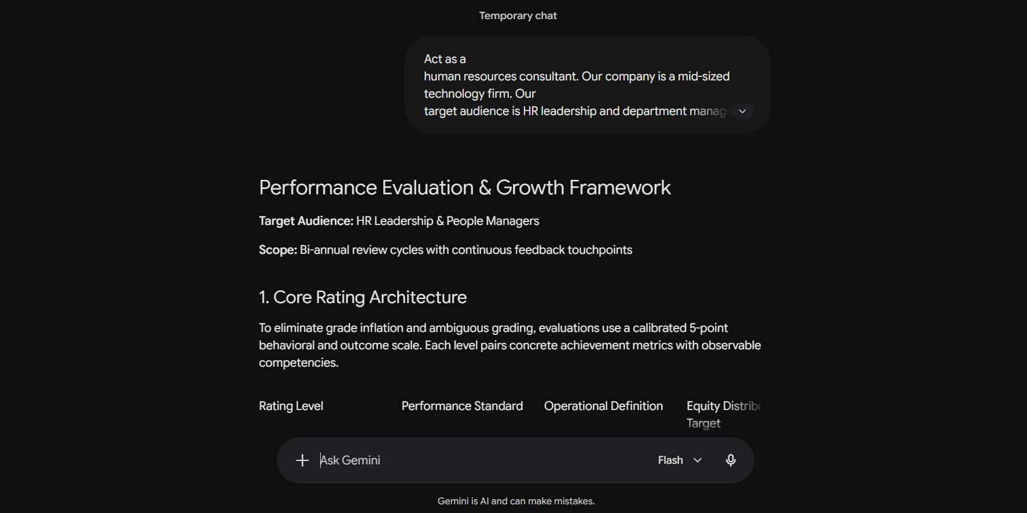

Improved Prompt (Type 2):
Act as a human resources consultant. Our company is a mid-sized technology firm. Our target audience is HR leadership and department managers. Create a comprehensive performance evaluation framework that ensures fairness and consistency across diverse teams, identifies key performance indicators, and provides actionable recommendations to improve employee satisfaction and productivity. Present the output as a structured HR report with clear tables, rating scales, and practical guidelines.

Example:
Input: "Design a performance evaluation framework for Google’s engineering teams."
Output: "Framework includes standardized KPIs such as code quality, project delivery timelines, collaboration scores, and innovation metrics. Evaluation uses a 5-point rating scale with clear guidelines to ensure fairness across teams."

Now, using the same style, generate a performance evaluation framework for our company.

Output:
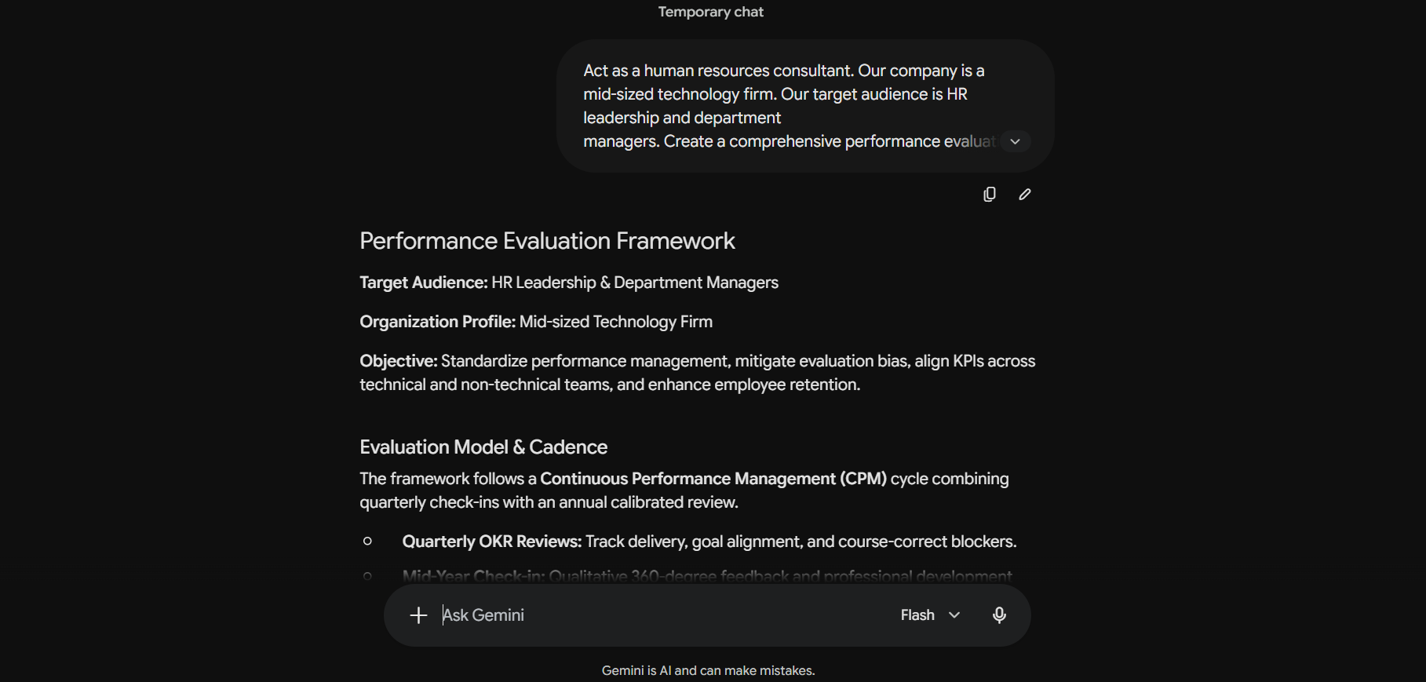

Marketing Department

Problem Statement:
The marketing department struggles to build strong brand awareness in competitive markets, resulting in limited customer recognition and weaker market positioning.

Basic Prompt:
Company is struggling with Low brand awareness so how to fix this?

Output:
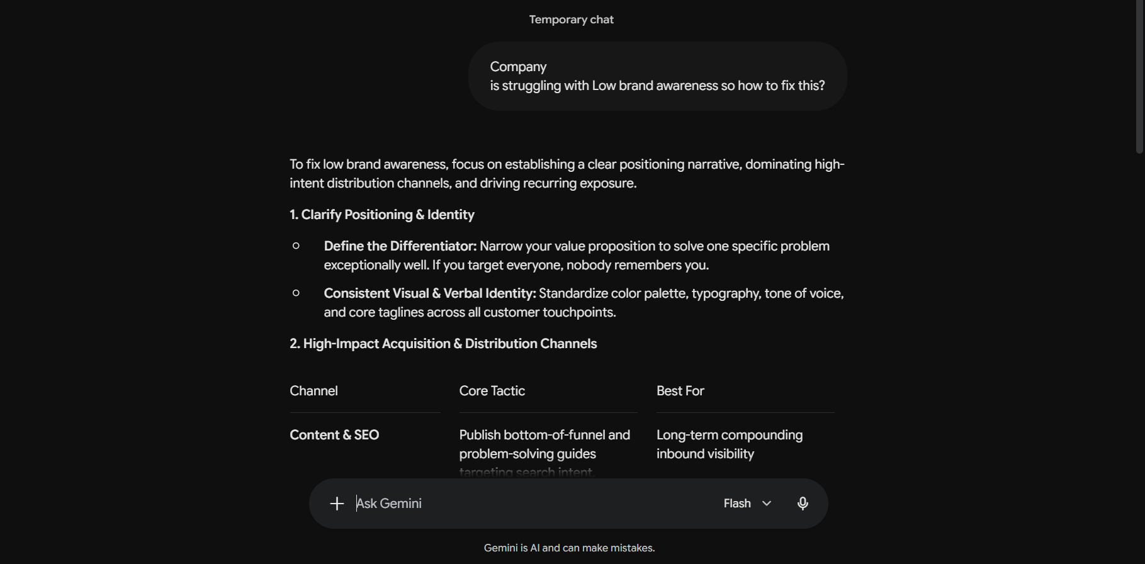

Improved Prompt (Type 1):
Act as a marketing strategist. Our company is a mid-sized consumer goods firm. Our target audience is the marketing leadership team and senior management. Create a brand awareness strategy that strengthens market positioning, improves customer recognition, and leverages both digital and offline campaigns. Present the output as a structured marketing report with clear tables, campaign ideas, KPIs, and actionable recommendations.

Output:
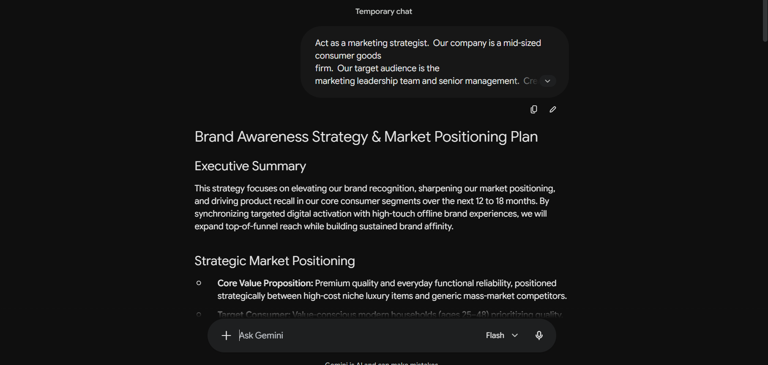

Improved Prompt (Type 2):
Act as a marketing strategist. Our company is a mid-sized consumer goods firm. Our target audience is the marketing leadership team and senior management. Create a brand awareness strategy that strengthens market positioning, improves customer recognition, and leverages digital and offline campaigns. Present the output as a structured marketing report with clear tables, campaign ideas, KPIs, and actionable recommendations.

Example:
Input: "Develop a brand awareness strategy for Coca-Cola in emerging markets."
Output: "Coca-Cola increased brand visibility through localized campaigns, influencer partnerships, and community events. KPIs included social media reach, brand recall surveys, and sales uplift in targeted regions."

Now, using the same style, generate a brand awareness strategy for our company.

Output:
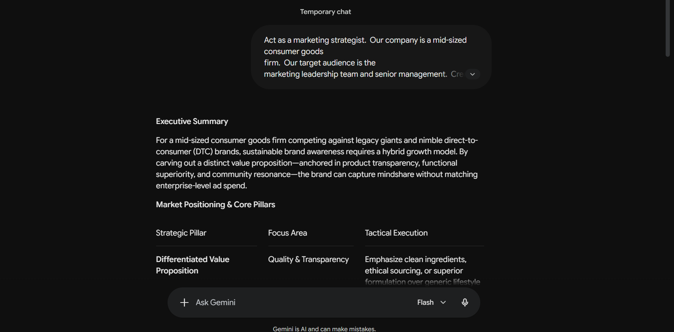

Key Finding

Prompt Engineering Strategies
- Basic Prompting (Baseline):
  - Style & Structure: Informal, unstructured, and conversational with minimal context.
  - Limitations: Lacks role definition, target audience framing, and output formatting guidelines.
  - Output Quality: Yields high-level, generic bullet points and troubleshooting tips across Finance, HR, Operations, and Marketing.
  - Best Use: Quick exploratory brainstorming or initial idea gathering, but insufficient for executive decision-making or formal reporting.
- Type 1 Improved Prompt (Zero-Shot Prompting via RCTF):
  - Framework: Applies the RCTF model (Role, Context, Task, Format) without supplying prior reference examples.
  - Role & Context: Assigns specialized domain roles (e.g., Financial Analyst, HR Consultant, Supply Chain Strategist, Marketing Strategist) tailored to mid-sized firms.
  - Audience & Output: Explicitly directs outputs to senior leadership and stakeholders, generating structured business reports with tables, KPI frameworks, Kraljic/risk matrices, and actionable recommendations.
  - Best Use: Standard corporate reporting, framework development, and formal business deliverables where clear guidelines suffice.
- Type 2 Improved Prompt (Few-Shot Prompting with Synthetic Benchmarks):
  - Framework: Supplements the RCTF framework with concrete, real-world industry reference examples (e.g., JPMorgan financial/fraud modeling, Google HR frameworks, Toyota procurement, Coca-Cola marketing campaigns).
  - Behaviour: Uses the provided examples to anchor formatting consistency and employs synthetic data/scenarios when proprietary company data is unavailable.
  - Output Quality: Delivers highly aligned, granular outputs with standardized rating rubrics, phased rollouts, and numerical breakdowns.
  - Best Use: Prototyping complex business frameworks, training models on specific stylistic standards, and generating actionable models without exposing confidential data.
Motives For Different Large Language Models (LLMs) Find By This Project
For this project, the specific motives for selecting each model are:
- ChatGPT (GPT-3.5): Selected because it provides a reliable balance of overall performance and broad accessibility.
- Claude (Sonnet 5 Medium): Chosen as Anthropic’s mid-tier model because it is highly optimized for complex reasoning and generating structured, formatted responses.
- Perplexity (Free Model): Included specifically to benchmark cost-effective, freely available AI solutions for practical business use.
- Gemini (Flash Model): Selected as Google DeepMind's lightweight model because it is specifically designed for speed and efficiency in real-time tasks

